FINAL PROJECT REPORT

‘’ Rapid Response for enhancing resilience and conflict prevention
in the communities hosting refugees
in Far North and Eastern regions of Cameroon ‘’
April 2015 - May 2016

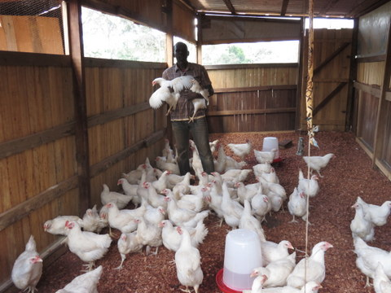
Mohammed Yassoumale IGA benéficiary in Garissingo Yokadouma (East-Cameroon)

Joint Project: UNDP, FAO, UNESCO
Under coordination of UNDP

I Project summary
Project title | Rapid Response for enhancing resilience and conflict prevention in the communities hosting refugees in the Far North and Eastern regions of Cameroon
Implementing area | The Far North and East regions in Cameroon
Implementing period | April 2015 – May 2016 (initially for 11 months with two-month extension)
Budget | 2,000,000 USD
Expected outcomes | Outcome 1: Social cohesion is strengthened through conflict prevention and economic empowerment activities for a peaceful and pacific coexistence  Outcome 2: Conflict prevention and management mechanisms are operational and inter-community dialogue is improved between refugees and host communities  Outcome 3: Management and coordination capacities of local administration are strengthened and basic social services are functional, operational and efficient
Implementing agency | UNDP
Implementing partners | FAO and UNESCO

II Introduction
Cameroon is situated in the middle of the African continent sharing borders with Nigeria, Chad and the Central African Republic (CAR) to the North and East. As the border between the Sahel and Central Africa, the country has been the meeting place of different cultures, ethnicities and tribes for centuries. The political and social situation in Cameroon has been relatively stable for many years. However, instability in neighbouring countries, in particular Nigeria and CAR has harmed the social and economic situation in Cameroon and raised concerns about possible sources of instability in the country. Eastern border areas were heavily affected by massive refugee inflow from CAR. In the North, Boko Haram was quite active in Nigeria and Boko Haram attacks created another inflow of refugees from Nigeria to Cameroon. Besides, Boko Haram started to enter Cameroonian territory to attack Cameroonian people as well. As a result, thousands of Cameroonian have fled from their homes as internally displaced persons (IDPs) and are living in foster care or occupying schools. In addition, East and Northern regions are among the poorest region in the country and recent humanitarian situation has further deteriorated the economic and social structure of the regions which is already suffering from extreme poverty. Furthermore, severe humanitarian situation could lead economic and social tensions among refugees, IDPs and host/local communities. Therefore, there was need to stabilise the regions and promote human security through a comprehensive peace building framework articulated around resilience, socio-economic empowerment, conflict prevention, reinforcement of institutional capacities for coordination and management for risk and development management.

III Expected Outcomes and Outputs
The project was elaborated to tackle the humanitarian situation explained above and to contribute to strengthen national capacity for sustainable development and build resilient growth using Human Security conceptual framework based on a multi-sectorial/multi-dimensional approach of issues related to resilience, social cohesion and conflict prevention. The project targeted communities affected by inflows of refugees and IDPs and outcomes were set as below with specific output.

Outcome 1: Social cohesion is strengthened through conflict prevention and economic empowerment activities for a peaceful and pacific coexistence
Output 1: Sustainable income generating activities (IGAs) put in place for 100 Households (HHs)
Output 2: Community infrastructures established/rehabilitated in 5 communities

Outcome 2: Conflict prevention and management mechanisms are operational and inter-community dialogue is improved between refugees and host communities
Output 3: Intercommunity conflicts management and prevention mechanisms (including community) based radicalization prevention platforms are set up and operational.
Output 4: Pasture Corridors of transhumance Platforms between nomadic herdsmen and local communities established

Outcome 3: Management and coordination capacities of local administration are strengthened and basic social services are functional, operational and efficient
Output 5: Emergency management mechanisms set up and functional in the targeted localities
Output 6: A plan to improve the quality of services to users set up in 5 Municipalities

IV Activities
During 13-month implementing period of the project, certain activities were conducted to achieve the outcomes. Details of the activities are explained here per each output.

Outcome 1: Social cohesion is strengthened through conflict prevention and economic empowerment activities for a peaceful and pacific coexistence

Output 1: Sustainable Income Generating Activities (IGAs) put in place for 100 Households (HHs)
Direct beneficiary: 8,104

1.1 Identify potential beneficiaries of IGAs
First, all sectoral administration officers, town representatives, community and religious leaders, members of civil society and UN partners discussed and developed vulnerability criteria such as presence of IDPs and refugees and number in HH. Beneficiaries of IGAs were identified based on the criteria. Total identified beneficiaries were 1,257 households and 29 local groups (around 6,604 individuals). Gender issue was taken into account during the identification of beneficiaries and IGAs. In total, 60 of 1,257 identified beneficiary HHs were female headed.

Initially the project targeted on 100 HHs but finally 1,257 HHs were effectively assisted for IGAs. The plan was to accompany 100 HHs but due to significant importance and need for IGAs in the affected communities, it was necessary to increase beneficiaries. Therefore, beneficiaries received less inputs than planned but more beneficiaries could receive inputs for IGAs. Finally, the number of beneficiaries became four times more than the initial indicators.

1.2: Perform the participatory identification of gender sensitive IGAs in 5 communities
In order to identify IGAs, the same actors of beneficiary identification participated in the discussion. Furthermore, to ensure gender aspects of IGAs, proposals by UN Women were taken into account and discussion with leaders and members of women’s association was organised. Four IGAs were approved by all stakeholders: chicken farming, pig farming, ruminant farming (sheep and goats), farming and processing agricultural products.

Table 1: IGA beneficiaries as identified
Community  (division, region) | Number of beneficiary identified | Designed IGA
Mokolo  (Mayo Tsanaga,  the Far North region) | 300 HHs | Farming
Mokolo  (Mayo Tsanaga,  the Far North region) | 3 GIC | Processing agricultural products
Mokolo  (Mayo Tsanaga,  the Far North region) | 40 HHs and 3 groups | Chicken farming
Mokolo  (Mayo Tsanaga,  the Far North region) | 25 HHs | Ruminant farming
Mora  (Mayo Sava,  the Far North region) | 250 HHs | Farming and processing agricultural products
Mora  (Mayo Sava,  the Far North region) | 2 GIC | Processing agricultural products
Mora  (Mayo Sava,  the Far North region) | 40 HHs and 11 groups | Chicken and ruminant farming
Mora  (Mayo Sava,  the Far North region) | 25 HHs | Ruminant farming
Kousseri,  (Logone et Chari,  the Far North region) | 250 HHs | Farming
Kousseri,  (Logone et Chari,  the Far North region) | 40 HHs | Chicken and ruminant farming
Kousseri,  (Logone et Chari,  the Far North region) | 25 HHs | Ruminant farming
Yokadouma  (Boumba et Ngoko,  East region) | 100 HHs | Farming and processing agricultural products
Yokadouma  (Boumba et Ngoko,  East region) | 2 GIC | Processing agricultural products
Yokadouma  (Boumba et Ngoko,  East region) | 11 HHs and 6 groups | Chicken farming
Yokadouma  (Boumba et Ngoko,  East region) | 15 HHs | Pig farming
Batouri  (Kadey,  East region) | 100 HHs | Farming
Batouri  (Kadey,  East region) | 3 GIC | Processing agricultural products
Batouri  (Kadey,  East region) | 16 HHs and 9 groups | Chicken farming
Batouri  (Kadey,  East region) | 15 HHs | Pig farming

1.3 Set up mechanisms to accompany the HH to put in place gender sensitive IGAs in 5 communities
1.4: Provide technical, material and financial support
1.5: Monitor the scheme
With support of various sector stakeholders and authorities of the project areas, participatory monitoring mechanisms were established. Each activity was monitored by experts and activity beneficiaries could reach them when there were technical challenges and beneficiaries themselves were encouraged to exchange with other beneficiaries. Also regular follow-up meetings were organised to check progress and to discuss common challenges among beneficiaries in the same activity. From gender aspect, female headed HHs and women’s associations/groups were prioritised during distribution of seeds, agricultural inputs and processing units.

1) Livestock farming
The activities in livestock farming were monitored by a zoological technician and two engineers and technical support to the beneficiaries was provided. Beneficiaries were received livestock inputs such as chicks, young pigs and small ruminants (sheep and goats) and feedstuff. Beneficiaries are very keen to bring their contributions (e.g. labour and local materials) to build shelters livestock but they did not have expertise. So they requested the experts to provide their expertise. For a month 135 shelters have been constructed by themself in the Far North region and 198 shelters have been constructed by the beneficiaries in East region.

Chicken farming
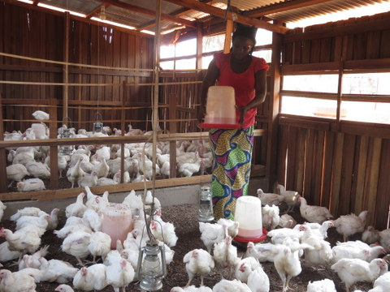
147 HHs in host communities benefited from chicken farming activity while 9 groups of refugees and 20 groups of host communities such as GIC, have also received. In the East region, each group and HH received 25-50 chicks and in the Far North each group and HH received 10 local chickens for breeding. After a 45-day growth cycle, the beneficiaries of chicken farming were able to sell their products at local. While HHs and groups of IDPs and host communities could go to Yaoundé to buy new chick and chicken with earned income, groups of refugees had difficulty to access to next investment because refugees have been restricted for movement and it was not easy to find new chick and chicken outside big cities like Yaoundé. Therefore, some groups started ruminant farming instead of chicken farming because ruminant is available locally.

Ruminant farming
Ruminant farming was implemented only in Far North region based on IGA identification discussion and religious and culture concerns. 75 HHs mostly composed of IDPs including female headed IDP HHs receive ruminants (six sheep/goats per HH). Other necessary materials like oil cake and vaccine were also distributed to the beneficiaries. Distributed ruminant grow and beneficiaries have succeeded breeding. Beneficiaries have kept farming and breeding and ruminants serves as a bank for beneficiaries. When they need to pay for schools and health care, some ruminants were sold.

Pig farming
Pig farming was implemented only in East region based on IGA identification discussion. A training session focused on production techniques, breeding, nutrition and swine health was organised for pig farming beneficiaries. Each HH and group received three pigs (a male and two females) and their food (50kg x 5). Two watering places with 8L capacity made by concrete were set up per HH and group. Veterinary materials such as anthelmintic, parasiticide, iron, vitamin, disinfectant, serum, vaccine were provided to Ministry of Livestock, Fisheries and Animal industries (MINEPIA) technicians to treat distributed pigs. Distributed pigs grow and are utilised for breeding. Pigs are also used like a bank as ruminant case.

2) Farming and processing agricultural products
Farming
800 HHs in the Far North region (Mokolo: 300, Mora: 250, Kousseri: 250) and 200 HHs (Yokadouma: 100, Batouri: 100) received agriculture input such as seeds and fertiliser. Each HH harvested vegetable like onion, garlic, lettuce, carrot, leek and tomato based on agricultural season and sold them to markets

Processing agricultural products
Two types of mills (for cereal and vegetable) were distributed to ten groups of GIC (Mokolo: 3, Mora: 2, Yokadouma: 2, Batouri: 3) to process agricultural product and beneficiaries could generate income through selling processed products at a higher price than raw material.

3) Gender aspect
Strong involvement of women was observed particularly in the processing units. Nice of ten distributed mills are managed by local women groups composed of 45 women in total. This was also seen in agricultural activities and 250 female headed HHs received agricultural inputs such as vegetable seeds.

1.6: Promote fuel efficient improved stoves for 100 HHs
This activity was implemented only in the Far North region because social pressure related to natural resources on host communities was considerable compared with East region due to scarcity of natural resource. Beneficiaries were identified in collaboration with local authority of Ministry of Environment, Nature Protection and Sustainable Development (MINEPD), traditional leaders and administration of three divisions. 1,500 beneficiaries (1,415 women and 85 men) received improved stoves. By using an improve stove, each HH needs less wood. Distribution of improved stoves contributes not only to fighting against deforestation and nature protection but also to pacific coexistence among refugees, IDPs and host communities.

Output 2: Community infrastructures established/rehabilitated in 5 communities
Direct beneficiary: 10,500

2.1: Rehabilitate/build infrastructures (including markets) in 5 selected localities
Dialogues with authorities at central and local levels along with the communities were held to identify which infrastructures were rehabilitated/constructed and their sites. It was decided to construct and rehabilitate livestock markets. Consensual criteria were defined to identify intervention sites: accessibility for IDPs, host communities and refugees if applicable, guarantee that markets would be useful for surrounding communities, alignment with local priorities, site being already used as informal market. Under the criteria, five sites were identified: Mokolo, Mora, Kousseri in the Far North region and Batouri and Yokadouma in East region. Land Award Certificates which serve land ownership issued by sous-prefet or mayor were obtained for five sites to prevent any conflict over market installation. Market plans (see one example in annex) were proposed by MINEPIA. Three livestock markets were constructed in Mora, Yokadouma (as a part of an integrated market) and Batouri and two markets were rehabilitated in Mokolo (as a part of an integrated market) and Kousseri. The market is composed of food part (cereal, vegetable and meat) and livestock part.

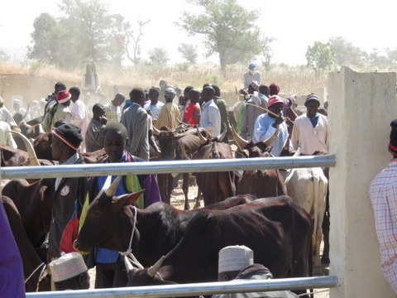
Five constructed/rehabilitated livestock markets have increased economic activity in the areas and more than 10,000 men and women on average use the markets every week. Concerning livestock, while 200-300 animals/market day are sold at rehabilitated Mokolo market, 100-120 animals/market day are dealt at newly built Mora market. A rehabilitated Kousseri market is a big market selling 500-800 animals/market day as a frontier market and it attracts livestock farmers not only from Cameroon but also from Chad, Soudan, CAR, Nigeria. The markets become places of life, great community hubs and essential economic exchanges areas. The markets serve as a proof of community tie creation, peaceful coexistence and dialogue between the host communities, IDPs and refugees. The creation of desire to live together and to strengthen social cohesion between people through the markets is an added value.

Outcome 2: Conflict prevention and management mechanisms are operational and inter-community dialogue is improved between refugees and host communities

Output 3: Intercommunity conflicts management and prevention mechanisms (including community) based radicalization prevention platforms are set up and operational.
Direct beneficiary: 511

3.1: Identify potential types of conflicts and concerned populations in the 5 communities
The existing conflicts and their resolution mechanisms were assessed at the local level in Mokolo, Mora and Kousseri in the Far North region. The survey helps to prepare a concrete capacity development plan to tackle tensions between IDPs, refugees and host communities. The survey finds some interesting local conflicts as tensions between farmers and livestock farmers, conflicts over natural resources and battles for land.

3.2: Support the setup of the platforms for local dialogue, planning and mediation comprising of local authorities, traditional leaders, local communities
A study was conducted to analyse existing platforms for local dialogue, planning and mediation. Socio-anthropological study was done and concerned information on conflict situation was collected. Besides, existing mechanisms for prevention, management and resolution of conflict was quickly analysed. Based on the study, training modules on conflict prevention and management for key actors such as youth, youth’s supervisors, media and community leaders were elaborated. Based on the modules, certain workshops were organised by UNESCO. Two workshops were for 30 young leaders. First one was about need identification and elaboration of awareness tool and community mobilisation and second one dealt with conflict prevention, management and resolution in and outside school environment. Another workshop was organised on capacity building to implement strategies and activities of youth platform of conflict prevention and promotion of peace culture in and outside schools. The workshop targeted youth’s supervisors, for example clubs, high schools, multifunctional centre for promotion of youth, national youth council and centre for promotion of women and family. Also an intercommunity conflict management and prevention mechanism has been set un in each community in Mora, Mokolo and Kouserri in the Far North region and Batouri and Yokadouma in East region.

3.3: Set up an operational platform of Youth Ambassadors for Peace
Two activities were implemented to complete this activity. In the Far North region, the pool of Youth Ambassador for Peace” from different youth structures and communities was created, and UNESCO trained and launched youth ambassador for peace” process in schools. In the Far North and East regions, UNDP in partnership with an International NGO (Mifalot) and Israeli embassy in Cameroon, organized trainings on sport and social values.

UNESCO
85 youths and adults from colleges and schools were selected as youth ambassadors for peace. 35 youth ambassadors of peace (23 boys and 12 girls) and 23 supervisors from schools and youth associations in Mayo Tsanaga, Mayo Sava and Logone et Chari divisions received training on living together in peaceful coexistence. In addition to schools, three youth ambassadors for peace were selected in each community: Mokolo, Mora and Kousseri. Working plans were developed with them and the youth ambassadors for peace are very active in outreach on peace within their schools and communities. Trained youth ambassadors for peace were also visible on social media animating discussions on peace and social cohesion.

UNDP with an International NGO
Two seminars were organized. The first seminar was for 48 physical education teachers in East region and the second was for 50 physical education teachers from the Far North and East regions and 300 students in East region.

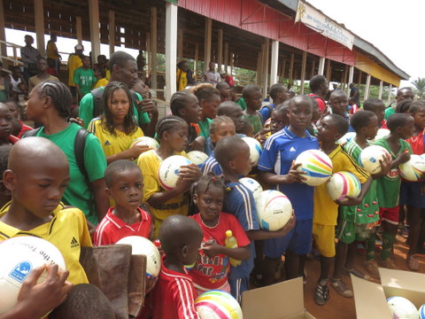
As the first seminar, a one-week workshop was organized for 48 physical education teachers (10 women and 38 men) in Bertoua. The general goal of the workshop is to reinforce trainers’ capacities from Yokadouma, Batouri and Bertoua and other localities hosting refugees from Central Africa Republic, to improve their knowledge on key values such as the leadership, social accountability, fair play, social cohesion, and patience in relationship with other communities and the acceptance of defeat. The teachers diffused what they acquired during the seminar to youth in their communities and youth shared it with their school mates and friends in schools and their communities. For example, certain teachers organized training session on football and its values with youth ambassadors for peace (850 boys and 650 girls in total) once a week. Moreover, seven civil servants at high level in the regions were also trained to follow up the activities.

The second training seminar on sports as a social cohesion tool was organized for 50 physical education teachers (15 women and 35 men). The teachers came from areas where refugees and IDPs are present such as Lom & Ndjerem, Kadey Boumba & Ngoko divisions in East region and Diamaré and Mayo Tsanaga divisions in the Far North region. They were given practical exercise to train 300 students in Bertoua in East region. As the previous session, the seminar focused on capacity building and on integration of social values ​​at the center of sports such as leadership, cooperation, responsibility, patience, teamwork, justice, honesty, fair play and humility. The participants obtained capacity to rebuild social fabric of community cohesion.

3.4: Strengthen capacities of local administration and leaders and local media in the field of peace building and conflict prevention
In order to strengthen capacities, 35 from local administration and leaders from five intercommunity conflict management and prevention mechanisms received training on conflict prevention and peace building. For local media, firstly training on social cohesion was organised and its target was local media people (15 men and 5 women) having a role of disseminating information. This seminar dealt with awareness in information processing and many other practices and expertise in journalism. Another workshop on need identification and capacity building was organised for 20 facilitators/technicians in radio production and diffusion to promote peace and pacific coexistence in communities through local languages. Produced programme by the training/workshop was diffused through four radio stations (CRTV, FM Kousseri, Sava FM and Radio Echos Desmontagnes) twice a week for six months. The programme was also used by youth for collective listing as club animation in and outside schools.

Output 4: Pasture Corridors of transhumance Platforms between nomadic herdsmen and local communities established
Direct beneficiary: 30,000

4.1: Support the identification of the sites
4.2: Identify potential solutions to deal with Pasture Corridors of transhumance platform
The survey on pasture corridors in East and the Far North regions was conducted and the findings of the diagnostic are as follow:

- Vaccination parks are woefully inadequate numbers in all six districts of Kadey division and they do not exist in districts of Boumba and Ngoko division.
- Rest areas for livestock are concentrated in the capital of Kadey division and they are insufficient in other districts or even none in Ndem Nam district. In Boumba and Ngoko district, the rest areas are non-existent.
- In all districts of two divisions, no drilling for watering livestock.
- Seven crossing points are identified in the capital of Kadey division.
- Host transhumance areas can find five in Batouri district and three in Ndem Nam districts and eight areas are insufficient regarding present needs.
- There are certain vaccination parks in the Far North region which were under construction by population initiative, especially around Mindif but assistance is necessary to finalise the construction, for example casting, installing galvanised tubes.
- Modern parks exist but they suffer from degradation at different levels. The rehabilitation is recommended for them.

Based on the survey, seven sites such as Yokadouma and Batouri in East region and Buenguel-Boboyo, Douroum, Guidiguis, Mindif and Kalfou in the Far North region were identified as intervention sites. As a potential solution, a lot of shortages and lack of infrastructure such as vaccination parks and water points and problem of territory utilisation such as rest areas and host transhumance areas were revealed and construction/rehabilitation of infrastructure related to transhumance, in particular vaccination parks was defined as a priority strategy for corridors of transhumance platform.

4.3: Operationalize the strategy
The construction/rehabilitation of infrastructure was managed by FAO and MINEPIA and two vaccination parks were constructed in Yokadouma and Batouri in East region. In the Far North region, some vaccination parks existed but they were not operational because they were destroyed and abandoned due to conflicts. Therefore, through rehabilitation, five vaccination parks (Buenguel-Boboyo, Douroum, Guidiguis, Mindif and Kalfou) have been revived.

Outcome 3: Management and coordination capacities of local administration are strengthened and basic social services are functional, operational and efficient

Output 5: Emergency management mechanisms set up and functional in the targeted localities
Direct beneficiary: 3,000,000 (estimated population in four divisions in two regions)

5.1: Support the development of emergency plans in the targeted districts (Departments)
5.2: Support the mainstreaming of emergency into Council development plan
5.3: Train local emergency coordination committees and local administrations on specific targeted topics
5.4: Strengthen capacities of the regional bodies and municipal focal points for local management of emergencies
Training session was organised for each region of the Far North and East and 250 stakeholders participated in the session. Participants were local authorities at a highest level, civil servants, members of division committees of crisis and civil society from Logone et Chari, Mayo Sava and Mayo Tsanaga divisions in the Far North region and Kadey and Boumba and Ngoko divisions in East region. An emergency/ORSEC plan is composed of two plans: a prevention plan and a relief plan and at different level like an emergency sensitive council development plan and an emergency management plan. During the training, different topics was discussed for prevention and relief such as general concept of emergencies, risk and disaster management before, during and after crisis, different types of emergency plan, risk identification, monitoring means, information and communication channels. Drafts of prevention and relief plans were elaborated for four divisions excluding Logone et Chari which have already had an emergency/ORSEC plan. Each draft was later enriched by the collection of data on risks and disasters and was validated by civil protection in each division. This allows setting up three measures: early warning measures, safeguards and response measures. In each measure, details were given on what to do in case of emergency, how to do so, on what is available in different jurisdictions and the needs for capacity building of the structures. Through development of emergency/ORSEC plans, local stakeholders such as administrative authorities and local representatives were trained in disaster management in the context of climate change with focus on the risk types of divisions, safeguard measures, the definition of intervention tasks and sectors by various institutional partners, restructure by "ORSEC services" as well as the identification of monitoring/evaluation of risk prevention and management strategy.

Output 6: A plan to improve the quality of services to users set up in 5 Municipalities
Direct beneficiary: 2,721,463 (estimated population in five municipalities)

6.1: Provide support to improve the quality of services in municipalities
Each diagnosis of service quality was conducted for five municipalities: Mokolo, Mora and Kousseri in the Far North region, and Yokadouma and Batouri in East region. The study found a structural problem as an outstanding weakness. The structural chart the municipalities provided was not implemented. This was caused by inadequate profiles of personnel, low qualification staff and low ownership of their mandate. Their performances were not structured because of nonexistence of manual procedures and monitoring and evaluation tools. The absence of a business plan and lack of leadership at the senior technical management staff level were observed. Based on the diagnosis, support/reinforcement plans were developed for five municipalities. They provide orientation to improve the quality of service, for example through elaboration of manual, meeting organisation, utilisation of radio and rehabilitation of structures.

V Achievements
As a quantitative aspect, the achievements of the project can be seen through the indicators. In all outcomes and all output, set targets are accomplished.

Table 2: Achievement overview by indicators
Indicator | Target | Achievement
Outcome 1: Community economic empowerment strengthened in the Far North and East regions of Cameroun through improved infrastructure of peace, income generation and community infrastructure establishment/rehabilitation

Output 1: Sustainable income generating activities (IGAs) put in place for 100 Households
Number of households having benefited of IGAs | 100 | 1,257  (+ 29 groups)
Number of HHs receiving improved stoves | 100 | 1,500

Output 2: Community infrastructures established/rehabilitated in 5 communities
Number of community infrastructure built/rehabilitated | 5 | 5

Outcome 2: Conflict prevention and management mechanisms are operational and inter-community dialogue is improved between refugees and host communities

Output 3: Intercommunity conflicts management and prevention mechanisms (including community) based radicalization prevention platforms are set up and operational
Number of intercommunity conflict management and prevention mechanisms set up | 5  (one per council) | 5
Number of media covered by training /sensitization on peace building and conflict prevention | 3 | 4

Output 4: Pasture Corridors of transhumance Platforms between nomadic herdsmen and local communities established
Number of corridors of transhumance Platforms between nomadic herdsmen and local communities established | 4 | 7

Outcome 3: Management and coordination capacities in emergency and basic social services provision of local administration are strengthened for improved functionality, operationally and efficiency

Output 5: Emergency management mechanisms set up and functional in the targeted localities
Number of committees trained in emergency management | 2 | 5
Number of emergency plans developed | 2 | 4
Number of emergency sensitive council development plan | 5 | 4
Number of updated/elaborated emergency management plan | 2 | 4

Output 6: A plan to improve the quality of services to users set up in 5 Municipalities
Number of plan developed | 5 | 5
Number of quality diagnosis performed | 5 | 5

Furthermore, each activity touched beneficiary directly through IGAs, construction/rehabilitation of markets and vaccination parks and training sessions on pacific coexistence, social cohesion, emergency committee, workshops/trainings about elaboration of emergency plans and improvement of quality of service.

Table 3: Number of beneficiary
Output | Direct beneficiary
Output 1: Sustainable income generating activities (IGAs) put in place for 100 Households | 2,757
Output 2: Community infrastructures established/rehabilitated in 5 communities | 10,500
Output 3: Intercommunity conflicts management and prevention mechanisms (including community) based radicalization prevention platforms are set up and operational | 511
Output 4: Pasture Corridors of transhumance Platforms between nomadic herdsmen and local communities established | 30,000
Output 5: Emergency management mechanisms set up and functional in the targeted localities | 3,000,000
Output 6: A plan to improve the quality of services to users set up in 5 Municipalities | 2,721,463
Total beneficiary | 5,765,231

In addition, beneficiaries felt difference from before the project. There is certain testimony of beneficiaries, in particular IGAs and local infrastructure as qualitative achievement (See annex 1 for more stories).

GIC Kelomessa (beneficiary group of pig farming), Yokadouma in East region
Before joint the project, the activities of the group were limited and a main activity was mutual labour support. For example, seeding and harvest seasons when a lot of labour is necessary, members worked together for each member’s field. It was not for income generation but for self-c1onsumption. Since the group received pigs, the group was restructured and each member was given specific task for pig farming. Pigs are mature and they will be sold soon. Generated income will be used for health care for family, education for children and other social affairs.

Ms. Garoua Tewe (beneficiary of Farming), Mokolo in the Far North region
I received seeds of carrot, cabbage and rave, fertiliser and certain materials for horticulture. It was the first time to receive a lot of good quality seeds and I could harvest large quantity of vegetable. I went to the market to sell my products for several times and I could earn enough money to pay for tuition fees of eight children. It had not been ever easy to pay for them

Ms. Hawa Salimatou (beneficiary woman IDP of an improved stove), Mora in the Far North region
I am happy to receive an improved stove because my chore to find wood by walking more than ten km was not easy. Particularly as an IDP, it was difficult for me so because land belongs to someone else and natural resources like wood are scarce. Sometimes I was blamed by land owners not to pass their land and I suffered from verbal and physical abuse. However, now with an improved stove, I am free from conflicts with community members because it is enough to pick up just some dry stalks of millet to cook.

Mr. Lamine Hawal (beneficiary as a livestock market user), Mokolo in the Far North region
Before a livestock market was rehabilitated, it was no area to control livestock and sometimes animals run away. They attacked women and damaged goods in the market and livestock farmers refrained from going to Zamaï market in Mokolo and intended to go other markets which have appropriate livestock market in order to avoid receiving complaints. Finally, some of them went to vegetable markets. However, there is stockyard in the market and it is not necessary to worry about livestock’s escape and damage to the market. Conflict between women and livestock farmer do not exist anymore and it became a thing of the past. It would be ideal that a problem of a slaughter house is solved as well because there is no specific place for slaughter and space of the market has been occupied for it without any protection. It would put visitors into danger.

VI Visibility
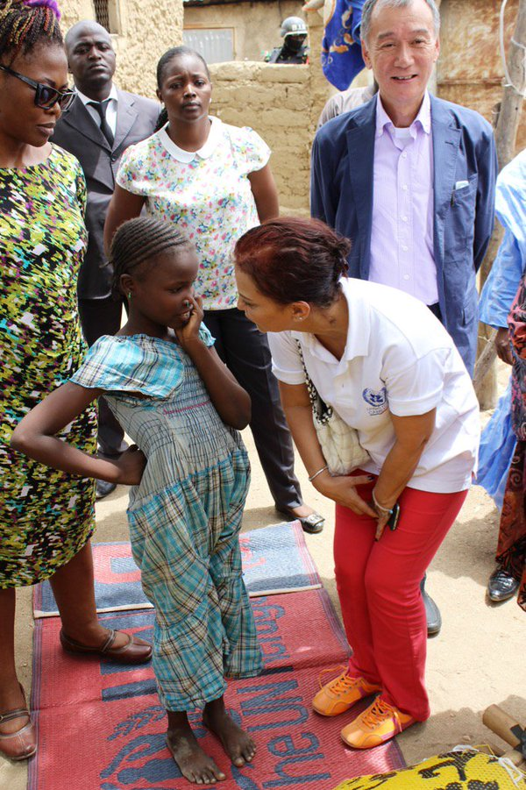
Main technical support was implemented by UNESCO to devise a visibility framework and to implement it and each agency complemented this effort with many initiatives to make sure the visibility of the Government of Japan as a donor. A media journey was organised in February with more than ten local media to produce articles and to broadcast on the project achievements on community radio. For one week, the support of the Government of Japan and its added value to the early recovery efforts was highlighted in the local media like local radio emission. More than 5,000 leaflets and visibility items such as visibility plate and T-shirts were distributed to stakeholders in the field like beneficiary of IGAs and youth ambassadors for peace to assure that Japanese contributions were well known. FAO issued a CD on the Income Generating Activities implemented in Batouri, Yokadouma, Mokolo, Mora and Kousseri and UNDP realized a 7-min video showing the major achievements and the perception of the stakeholders. The Ambassador of Japan, Mr. Kunio Okamura, visited to the Far North region in order to observe humanitarian situation and the project activities in April. He visited to Mokolo which is one of the project sites and Minawao refugee camp and met refugees, IDPs, beneficiaries from local population, local authorities and a traditional leader for dialogue.

VII Challenges/Constraints and Lessons learnt
During the implementing period of the project, there were certain challenges and constraints. Major challenges/constrains and lessons learnt were:

Huge demand for IGA assistance
Based on discussion on identification of beneficiaries with all sectoral administration officers, town representatives, community and religious leaders, members of civil society and UN partners, huge demand for IGA assistance was revealed. Moreover, vulnerability was spread across the communities and it was difficult to leave behind vulnerable people. Therefore, initial target of IGAs was 100 HHs but it was decided by all stakeholders to extend beneficiaries to 1,257 HHs although beneficiaries received less input than planned but more beneficiaries could receive inputs for IGAs.

Decision of intervention sites of markets
A dialogue with authorities at central and local levels along with the communities was held to identify the sites of the markets. It was very challenging because local authorities tended to use this activity as a political mean to please their respective community and each of local authority has its own agenda and strategy. In order to avoid inter-community dispute, the stakeholders agreed to establish criteria and consensual criteria were defined as accessibility for IDPs, host communities (and refugees if applicable), guarantee that markets would be useful for surrounding communities, alignment with local priorities, site being already used as informal market. Based on the criteria, five markets were constructed/rehabilitated in Mokolo, Mora, Kousseri in the Far North region and Batouri and Yokadouma in East region.

Shortage of qualified construction enterprise in the field
The launching of market construction/rehabilitation was delayed because it was difficult to find qualified and trustworthy enterprises in the fields, i.e. the Far North and East regions. In old project in the Far North region, UNDP had experience to work with construction enterprises based in Yaounde but the enterprises were not capable to deliver on time and it ended up with serious disagreement with them. As the lesson learnt, we prioritised contracting with local based constructors to make sure that they were physically based in the intervention areas and could be easily monitored. However, it took time to search local based and capable enterprises.

Security instability in the Far North region
The procedure of enterprise identification for a livestock market in Kousseri where the majority of incidents by Boko Haram occurred was further delayed because of the security threat. Incidents related to insecurity such as suicide bombings throughout the Far North region kept growing and movement of UN agencies in the Far North region suffered from severe restrictions due to UNDSS advisory. The measure of monitoring the activities by local authorities was taken to overcome the security challenge. UNDP have developed a partnership with division and district delegates to pursue the activities in the field. A training session on planning and monitoring was organised for 20 delegates who monitored the activities including a livestock market construction in Kousseri. The delegates ware received appropriate tools for implementation, monitoring and reporting. This option allowed the continuation of the project implementation although management cost increased. Every two or three weeks, a follow up session was held locally to have a feedback from them, exchange on constraints and provide guidance on appropriate mechanisms to address challenges.

Extension of the project period
The project period needed to be extended for two months with no additional cost due to the main reasons explained above such as shortage of qualified enterprise in the field, security instability. These challenges were overcome by the measures in the previous explanation. Moreover, start-up for emergency plans was slow with local authorities because the concept of early recovery was not well aware among them. It took time in the beginning but through dialogue and workshops with them, the concept was absorbed by them and emergency plans were well developed.

VIII Conclusion
As the achievements shown, the project financed by the Government of Japan contributed to strengthen national capacity for sustainable development and build resilient growth using Human Security conceptual framework based on a multi-sectorial/multi-dimensional approach of issues related to resilience, social cohesion and conflict prevention in the Far North and East regions of Cameroon. More specifically, social cohesion is strengthened through conflict prevention and economic empowerment activities for a peaceful and pacific coexistence. Conflict prevention and management mechanisms are operational and inter-community dialogue is improved between refugees and host communities and management and coordination capacities of local administration are strengthened and basic social services are functional, operational and efficient. Total direct beneficiaries are estimated as 5,765,231 through the project.

However, incidents by Boko Haram have been continuing and further IDPs have occurred in the Far North region. UN agencies including UNDP and international and national NGOs have continuously intervened in the region through various initiatives to support the efforts of the Government of Cameroon. UNDP has received the funds from the Government of Japan to tackle new challenges in the Far North region. The project “Preventing Radicalization and Strengthening Early Recovery efforts of Women and Youth in Response to the Deteriorating Human Security Situation in the Far North of Cameroon” has been implementing with special focus on youth employment and prevention of radicalisation. Through the project, further vulnerable Cameroonian IDPs and population in host/local communities have been supported by the Government of Japan and the People of Japan.
Annexe 1 Témoignages
- Gic Kelomessae, Yokadouma
Avant notre adhésion au projet, notre groupement était un organe vide, dans la mesure où nos activités portaient sur des soutiens mutuels en main d’œuvre ; C’est-à-dire lors de la semence des champs ou en période de récoltes, nous faisons le tour des champs de chacun des membres pour augmenter la main d’œuvre. Le produit de nos champs était destiné à l’autoconsommation et ne faisait aucun revenu.
Depuis que nous avons reçu les porcs, nous avons restructuré le groupement et responsabilisé chacun des membres sur des tâches précises, au regard de tout cela, notre fonctionnement actuel est meilleur que celui avant notre adhésion au projet. Les sujets reçus constituent le point rassembleur de tous les membres, car une grande part de l’avenir du groupement y en dépend désormais. Les porcs sont à maturité et les croissements seront pour bientôt, notre objectif est d’avoir dans un premier temps le maximum de têtes et dans un second temps procédé aux ventes la vente commencera bien après. Les revenus issus des ventes permettront de répondre aux besoins très nombreux des membres du groupement qui vont de la santé de nos familles, de l’éducation de nos enfants et d’autres qui sont d’ordre social.

- Tsafack Marie éleveuse de poulet de chair (Batouri)
Notre groupement de femmes avait reçu 80 poussins, nous les avons élevés suivant un processus de 45 jours avec l’accompagnement du zootechnicien de la délégation de l’élevage. Au terme du processus, nous avons écoulé la production et nous nous sommes réapprovisionnés en achetant 125 poussins qui suivent le processus habituel. Depuis notre adhésion au projet, nos rêves sont une réalité, nous envisageons agrandir l’espace et passer à une plus grande production, parce que le marché des poulets de chair offre des opportunités intéressantes. Ainsi, nous sommes des femmes différentes de celles que l’on a connues avant le contact avec le projet, aujourd’hui nous jouissons d’une indépendance qui grandira dans les prochains jours. Mais cependant, nous rencontrons beaucoup de difficultés liées à l’approvisionnement en poussins, dont les fournisseurs sont rares sans oublier qu’il faut faire des kilomètres sur une route très mauvaise pour atteindre l’unique fournisseur à Bertoua.
- Garoua Tewe culture maraichères (Mokolo)
J’avais reçu des semences de carottes, de choux, de bété raves, des engrais et du matériel, ceci m’a été d’un apport dans la mesure où je ne disposais pas d’un revenu ma permettant de les acheter. Cela fut un premier changement, car dans le passé je n’avais pas reçu autant de semences de qualité, et ceci constituait la raison d’un nouveau départ pour moi. Ma production fut très abondante comme elle ne l’a jamais été au point où je me suis rendu plusieurs fois au marché pour écouler le produit des champs, j’ai eu suffisamment d’argent qui m’a permis de payer la scolarité de mes huit enfants. Je voudrais relever que le paiement de la scolarité des enfants n’avait jamais été fait avec autant d’aisance que cette année, tout ceci grâce aux bonnes récoltes.

- Abdoulrahim culture maraichères (Mokolo)
Il commença son propos par des remerciements au peuple japonais, car au financement accordé à ce projet, il a retrouvé un travail utile. Avant son adhésion au projet, il n’avait jamais fait l’expérience des cultures maraichères et se contentait de cultiver du mil en période pluie. Entre temps, il restait oisif, situation dans laquelle il se laissait aller dans la consommation de l’alcool dont les conséquences étaient sources de conflit avec les autres membres de la communauté. Mais depuis qu’il a reçu des semences et qu’il pratique les cultures de contre saison, il s’est rendu utile davantage et n’est plus oisif, même sa consommation d’alcool est mieux maitrisée et il n’a plus des problèmes avec ses frères.

- Hawa Salimatou femme IDP utilisatrice de foyer amélioré
Je suis contente d’avoir reçu ce foyer amélioré, car ma corvée qui était celle de marché sur des dizaines de kilomètre à la recherche du bois n’existera plus. En tant que personne déplacée, la recherche des ressources tel que le bois n’est pas toujours aisée dans la mesure où elle se fait sur des terres appartenant aux autres. Il faut déjà relever le bois est une ressource de plus en plus rare et défendu par ce dont les terres en possèdent. Donc de temps en temps, lorsque vous faite surprendre par les propriétaires cela peut passer de la violence verbale à la violence physique. Aujourd’hui avec mon foyer amélioré, j’ serai à l’abri de nombreux conflits avec les membres de la communauté, car il me suffira de ramasser quelques tiges sèches de mil pour faire ma cuisine.

- Lamine Hawal Berger et utilisateur du parc à bétail
Avant la construction du parc à bétail, cet espace était vide et sans un véritable contrôle, les bêtes s’échappaient et faisaient des dégâts auprès des femmes et des marchandises qu’elles attaquaient dans le marché. Beaucoup de bergers préféraient allaient dans d’autres marchés de peur de répondre à une plainte contre eux du fait qu’une de leurs bêtes s’est retrouvée dans le marché des femmes. Avec la construction du parc à bétail, il existe un véritable contrôle sur le bétail, les bêtes n’ont plus la possibilité de s’échapper et d’aller faire des dégâts dans le marché des femmes, les plaintes contre les bêtes n’existent plus et le conflit entre les femmes et les bergers relèves du passé. Nous aimerons aussi voir les problèmes de notre abattoir se résoudre comme ce fut le cas pour le parc, car l’espace occupé pour l’abattage n’est pas protégé et comporte plusieurs risques pour les consommateurs.
- Saïbou Ousmanou Chef de centre Zootechnique et vétérinaire du marché de Zamaï
Quand j’arrivais à Zamaï en 2014, le marché à bétail n’était qu’un espace où se rassemblaient les bergers pour vendre leurs bétails, le travail était difficile pour nous, car nous n’avions pas la maitrise de la situation et même les recettes étaient très faibles car très peu d’utilisateurs de l’espace qui nous servait de parc refusaient de payer leur ticket. Le bétail venait de part et d’autres sans aucun contrôle augmentant ainsi les risques de contagion, bref le travail allait dans tous les sens sans réel organisation.
Depuis la construction du parc, nous maitrisons la situation et sommes mieux organisés, le bétail est contrôlé, les bergers s’acquittent de leur taxe, les enregistrements sont maîtrisés ; les entrées et sorties du bétail également, les recettes ont considérablement augmenté, les conflits entre bergers et d’autres bénéficiaires du marché sont maîtrisés, bref ce qui autrefois ressemblait à une cours de récréation a aujourd’hui un sens et les activités suivent désormais un objectif. Nous remercions le gouvernement japonais qui a mis à disposition les fonds qui ont conduit à la construction de ce marché, et qui par conséquent ont apporté de nombreuses solutions dans le secteur de l’élevage.

- Andélé Anne Marie
Avant ma rencontre avec le projet je pense que j’étais ignorante, depuis que j’ai été sélectionnée comme bénéficiaire, tout en changer en moi, dans la mesure où je me suis débarrassée de certaines habitudes causées par le désoeuvrage notamment la consommation d’alcool, qui me mettait en conflit avec mon entourage.
Aujourd’hui le projet me permet de construire un nouvel espoir pour moi, mes enfants et toute ma famille.

- Mme Adjondji Banji
Dans le passé, j’avais une porcherie mais en matériaux basiques et mes porcs souffraient beaucoup, cela me causait beaucoup de pertes. Il me fallait acheter des planches de temps en temps, faire l’entretien et changer les planches rongées par mes porcs. Les tôles que j’avais ne couvraient toute la porcherie, ainsi la période de froid les rendait fragile et entrainait des pertes. Pour l’aliment complet pour les nourrir je me rendais à Bertoua. Tout cela a engendré un abandon de l’activité de ma part.
A présent avec le projet, j’ai fait un effort de construire enclos en matériaux durables et mes porcs sont à l’abri des intempéries et j’assure bien son l’entretien et aussi son hygiène. Nous avons reçu une formation, ce qui est une grande première dans le département, nous avons reçu beaucoup de connaissances sur la façon de mesurer l’aliment, comment laver les animaux, le traitement, etc.
Je ne suis plus une charge pour mes parents, car je m’auto-emploie avec ma porcherie, je peux désormais m’occuper de moi-même, payer mes études et les frais de différents concours. A moyen et long terme, je compte agrandir la capacité de ma porcherie, voire même changé de site. Je pourrais approvisionner les consommateurs de viande de porc dans le quartier et avec ces revenus aider la famille à résoudre plusieurs problèmes.
Ma porcherie fait ma fierté dans la mesure où dans la famille, les gens me considéraient pour une femme sans ambition et qui avait échouée dans toutes ses tentatives d’entreprenariat, j’avais perdu le respect de la plupart de mes proches et ce m’avait fait perdre confiance et frustrait car, je n’osais plus rien entreprendre, mes journées étaient lourdes. Cependant, grâce au projet et à ma porcherie, j’ai pu me relancer et tous se sont rendus à l’évidence que je peux réaliser quelque chose de grand et du coup mon capital confiance s’est accru dans la famille, dans le quartier et dans la communauté. Les gens recommencent à me fréquenter et à me confier certaines tâches qui auparavant étaient réservées pour d’autres.

- Mr Tapondjou Roger
Mon expérience dans l’élevage a toujours été couronnée par un échec, une perte de toute une porcherie m’avait entrainé au découragement et à l’abandon.
Aujourd’hui avec le présent projet, nous avons reçu une formation, les abris des animaux sont en matériaux durables, les techniciens assurent un suivi permanent et les porcs sont vaccinés.
Nous aimerons créer une plateforme de tous les bénéficiaires qui servirait de cadre d’échange d’expérience et de concertation pour des éventuelles ventes.

- Mr Tolo Nguélé Ismaël
Avant le projet, je me battais seul à faire le petit élevage et la pisciculture, cela n’avait jamais été fait sans difficulté et le plus frustrant était la non atteinte des résultats qui engendrait l’abandon de l’activité.
A présent, le quotidien semble de plus en plus rassurant surtout que ces porcs sont de la bonne race et d’autant plus que nous avons des techniciens qui nous accompagnent. Ce qui nous laisse croire à l’avenir, par conséquent je peux à nouveau formuler des rêves.
Lorsque les membres de la communauté qui n’ont pas donnés le moindre crédit au projet ont assisté à la distribution du matériel de construction des abris, leur regard à changer même à mon égard, ils avaient compris le sérieux qui accompagne le projet. Beaucoup m’approchent pour savoir comment est-ce qu’ils peuvent aussi en bénéficier et se lancer dans cette activité.
J’ai appris de le travail d’électricien et les marchés sont rares, nous sommes mis en minorité face à la concurrence des techniciens venant des grandes villes, ce qui nous condamne à un chômage permanent. Aujourd’hui, ma vision par rapport au travail a changé, je suis plus porté sur mes activités d’élevage au détriment de celles de l’électricien.

- Gic Association coup de cœur
L’élevage tel que nous le faisons avant était très artisanal, car dans un enclos, nos porcs perdaient du poids, alors nous les laissons divagués dans le village pour se nourrir. Cette façon de faire engendrait plusieurs sources de conflits et de tension avec les voisins dont les porcs mangeaient les cultures et aussi avec la communauté musulmane qui ne supportait pas leur présence dans leur environnement. Ainsi, certains se faisaient éliminer par les frères musulmans et d’autres qui avaient endommagé les cultures se faisaient attraper par les voisins. La plupart du temps, nous étions convoqués chez le chef et même à la police pour répondre aux accusations et réparer les dégâts causés par nos porcs.
Aujourd’hui avec la réception de cette nouvelle race qui supporte vivre dans un enclos, plusieurs voire tous nos conflits avec les voisins et la communauté musulmane sont résolus, notre association est vue autrement, non plus pour créer des tensions et des conflits entre les communautés, mais celle qui désormais est au service de la communauté. Car nous espérons approvisionner la communauté en viande de porc, les revenus générés permettront de faire vivre l’association et de mieux assister ses membres.
Grâce à ces revenus nous espérons réduire les violences dont les femmes de l’association subissent face à leurs maris. En effet, le lieu de rassemblement de l’association est très éloigné du village, ce qui fait après les réunions, certaines femmes sont victimes de violences par leurs maris qui se plaignent qu’elles soient rentrées tard à la maison. Ainsi, grâce aux revenus générés par le projet, nous espérons construire une case de réunion sur la parcelle de terrain donnée par le chef à titre de récompense l’association pour l’absence des plaintes contre elle, depuis que nous avons reçu ces porcs.

- Association Zond Jognoul
Avec les revenus du projet, l’association compte scolariser le plus grand nombre d’enfants de ses membres, construire un hangar pour les rencontres, aménager la source du village.
- DJAOURO Ibrahima
Avant la construction du marché à bétail, nous assistions régulièrement aux conflits agropastoraux après la mise en place des cultures, car de nombreux bétails en divagation se retrouvent très souvent égarer dans les champs des agriculteurs et procèdent à la destruction des cultures. Ce qui de fait engendrait un conflit à la fois direct et ouvert entre éleveurs et agriculteurs, mais avec la construction du marché à bétail e son éloignement avec les habitats la question relative aux conflits agropastoraux trouve un début de solution dans la mesure nous disposons désormais des infrastructures telles que le parc à bétail, le parc vaccinogène, des bureaux pour le personnel et un magasin. La présence de ces unités permet de garder le bétail à un endroit sécurisé qui nous évite des divagations des bêtes souvent présentée comme une source parmi tant d’autres des conflits agropastoraux.
- MINDJOS Joséphine
Les achats de tomate se faisaient à plus de 300 KM de Yokadouma, du coup la revente sur le marché local se faisait à un prix élevé, plusieurs ménages ne consommaient presque pas la tomate en fruit, non pas parce qu’elles ne le voulaient pas, mais parce que leur bourse ne le leur permettait pas. Avec la distribution des semences de tomate, nous avons constaté un changement sur plusieurs échelles ; au marché la quantité de tomates offerte a augmenté, ce qui a eu pour conséquence directe la baisse du prix, par ailleurs, on a assisté à un engouement de la part des ménages dans la consommation de la tomate en fruit. Les vendeuses de tomate ne passent plus leurs commandes sur des centaines de kilomètres, car elles peuvent directement s’adresser aux producteurs locaux. Ce qui a pour avantage de réduire les distances, les dépenses, les risques d’accident et de perte de sa marchandise, le temps de se concentrer sur d’autres activités ménagères et aussi de bien se reposer. Mais la grande difficulté liée à cette activité est qu’elle ne se pratique intensément qu’en période de pluies, car les baffons et les cours d’eau sont presque asséchés.
- MATASSI Béatrice
Je suis la représentante de l’association des jeunes de Matakam, nous avons bénéficié d’un moulin pour la transformation des denrées alimentaires sèches. Avant sa réception, l’association avait pour principale activité l’agriculture, cependant nous rencontrions beaucoup de difficultés liées à la qualité de la semence, puis que ne disposant d’un revenu considérable pour acquérir la meilleure semence, nous pratiquons une agriculture sans intrants (fongicide, insecticide, engrais…), l’accès à une quantité suffisante en eau pour les cultures. Tout ceci avait pour résultat ; une production faible, très souvent destinée à l’autoconsommation par les différents membres. Ce qui suscitait le découragement de certains membres qui trouvaient que le travail en association était peu rentable et constituait une perte de temps.
Depuis la réception du moulin, nous avons diversifié nos sources de revenus et les recettes réalisées dans cette activité permettent de renforcer notre première activité principale en achetant la bonne semence et les intrants. Nous avons procédé à la première expérience, elle a conduit à des résultats encourageant qui ont permis à l’association d’épargner un peu d’argent. Malheureusement, les différentes interventions face aux pannes du moulin provoquent souvent une sortie rapide de cette épargne.
- Mr GOYA
Avant j’allais jusqu’à Douala pour acheter la semence, la production était quelques fois moyenne ou faible. Mais avec la semence que j’ai reçue, jamais je n’avais atteint un tel niveau de production depuis que je me suis lancé dans l’agriculture. 100g de semences pour 10 sacs d’oignons récoltés, pour moi c’est énorme. J’ai stocké une partie que je revendrai quand le produit se fera rare sur le marché avec ces revenus, je vais pouvoir résoudre plusieurs problèmes restés en suspens et préparer tranquillement la rentrée scolaire des enfants.
- OUMAR PADELBA
Avant je faisais de l’agriculture et mes productions étaient médiocre, car j’utilisais des méthodes très anciennes qui ne sont plus compatibles avec la qualité de nos terres cultivables. Alors avec l’arrivée du projet, J’avais reçu trois chèvres (2 femelles et 1 mâle), actuellement j’en ai neuf (9) et je pense qu’après deux mises basses encore j’en aurai une vingtaine. Tous les bénéficiaires connaissent une augmentation en termes de sujets et en sont très satisfaits.
- OUMARASSANE TALBA
C’est l’occasion pour moi de témoigner toute la gratitude des bénéficiaires du marché à bétail de Zamaï, nous avons mis sur pied des comités de gestion et d’entretien des infrastructures et les autorités n’ont ménagé aucun effort et aussi n’ont de cesse inculqué la notion d’appropriation.
- Mr JONAS Chef de poste agricole
Koza est une zone difficile à accéder, du coup, organiser des réunions avec les groupements de cette localité n’est pas du tout évident, ajouter à cela, les groupements sont presque inexistant. Aujourd’hui grâce au projet, nous avons assisté à une mobilisation rapide des groupements qui participent aux réunions et sont volontaires dans l’effort.

Annex 2 FAO REPORT

Projet ‘Rapid Response for enhancing resilience and Conflict prevention in the Far North and East regions of Cameroon’

CAMEROUN

Compte rendu final du projet
Intitulé du Projet | Rapid Response for enhancing resilience and Conflict prevention in the Far North and East regions of Cameroon
Code du projet | UNFA/CMR/038/UND
Pays bénéficiaire(s): | CAMEROUN
Gouvernement/autre(s) contrepartie(s): | Gouvernement Camerounais : MINADER, MINEPIA, MINEPDED  Agences des Nations Unies : FAO, PNUD et UNESCO
Budget approuvé (USD): | USD 351 400
date de démarrage | Mars 2015
date d’achèvement: | Mars 2016
Fonctionnaire technique principal | Sagnia Sankung et Cyprien Biaou (SFC)
Objectif stratégique / Produits de l’Organisation: | 5 - Increase the resilience of livelihoods to threats and crises  - 503 - Countries reduce risks and vulnerability at household and community level.  - 504 - Countries and regions affected by disasters and crises prepare for, and manage effective responses.
Initiative régionale / Domaine de priorité: | /
Résultats du Cadre de programmation par pays: | DP III : Elaborer et mettre en œuvre des politiques et stratégies visant l’accroissement de la résilience des ruraux aux catastrophes naturels et aux crises  Effet 3.2 : Les populations s’accommodent et se remettent mieux des effets des catastrophes et des crises pour recouvrer leurs moyens d’existence
préparé pour
le Gouvernement du Cameroun
par
l´Organisation des Nations Unies pour l´Alimentation et l´Agriculture FAO

Rome, Avril 2016

TABLE DES MATIERES
1-INTRODUCTION 5
1.2- DISPOSITIONS OFFICIELLES 6
2- OBJECTIF GENERAL DU PROJET 6
3-DESCRIPTION DES DIFFERENTES COMPOSANTES DU PROJET 6
3.1-COMPOSANTE CULTURES MARAICHERES 6
3.2-COMPOSANTE PRODUCTION ANIMALE A L’EST ET A DE L’EXTREME NORD DU CAMEROUN 7
3.3-COMPOSANTE CONSTRUCTION DES FOYERS AMELIORES (PROTECTION DE L’ENVIRONNEMENT) 8
3.4-COMPOSANTE UNITES DE TRANSFORMATION DES CEREALES. 8
3.5-COMPOSANTE REHABILITATION DES CORRIDORS DE TRANSHUMANCES 8
4- RESULTAS OBTENUS 9
4.1-Composante Cultures maraîchères. 9
4.2- COMPOSANTE PRODUCTION ANIMALE 9
4.3-COMPOSANTE UNITES DE TRANSFORMATION DES CEREALES. 10
4.4-COMPOSANTE CONSTRUCTION DES FOYERS AMELIORES (PROTECTION DE L’ENVIRONNEMENT) 10
4.5- COMPOSANTE CONSTRUCTION DES CORRIDORS DE TRANSHUMANCES 10
5-DIFFICULTES RENCONTREES 11
6- CONCLUSIONS 11
7-RECOMMANDATIONS. 11
7.1-Composante Elevage 11
7.2-Unités de transformations 12
ANNEXES 13

SIGLES ET ABBREVIATIONS
AVZ : Agent de vulgarisation de zone
ECAM : Enquête Camerounaise Auprès des Ménages
FAO : Organisation des Nations Unies pour l’Agriculture et l’Alimentation
IDP : Personnes déplacées internes
MINEPAT : Ministère du Plan et l’Aménagement du Territoire.
PAM : Programme Alimentaire Mondial
PH : Population hôte
UNESCO : Organisation des Nations Unies pour l’Education, la Science et la Culture.
UNDAF: United Nations Development Assistance Framework.
OS : Objectif Spécifique
OIM : Organisation Internationale pour les Migrations

1-INTRODUCTION
Les régions de l’Extrême- Nord et de l'Est du Cameroun sont connues comme étant vulnérables en termes d’indice de pauvreté et le mauvais progrès socio-économique par rapport au reste du pays. Ces indices de pauvreté sont les plus élevés par rapport à l’ensemble des indices du pays selon l’Enquête Camerounaise Auprès des Ménages (ECAM 3).
En plus, les manifestations régulières de changements climatiques influent sur la région de l’Extrême- Nord avec pour conséquence les sécheresses et les inondations qui mettent davantage la population locale dans une situation de vulnérabilité.
Au cours de ces 2 dernières années, le contexte humanitaire dans les zones limitrophes du Nigeria et de la République centrafricaine (RCA) s’est détérioré considérablement, d’une part par l’incursion de la secte Boko Haram et d’autre par l’instabilité politique et autres formes de criminalité des antibalaka. La Combinaison de ces deux évènements a entrainé une arrivée massive des Réfugiés au Cameroun et le déplacement internes des populations, d’où un nombre élevé de personnes déplacées internes (IDPs).
Certaines agences du Système des Nations Unies interviennent déjà dans la région et apportent une assistance aux populations affectées. C’est par exemple le cas de l’Organisation des Nations Unies pour l’Education, la Science et la Culture (UNESCO) avec la mise en place des cadres de dialogue et du Programme Alimentaire Mondial (PAM), avec des distributions de rations alimentaires aux populations déplacées internes et aux populations hôtes. Les besoins demeurant importants et urgents afin de permettre aux populations de reprendre une vie normale, par ricochet améliorer leur résilience aux crises et aux catastrophes. Selon les estimations du HCR (2016) de la région de l’Extrême- Nord 56.194 de réfugiés nigérians vivent au camp de Minawao, pendant que 30 000 réfugiés Nigérians (statistiques du HCR de 2016) continuent de vivre dans les familles d’accueil. Dans le même temps 198.890 réfugiés de la République Centrafricaine vivent à l’Est et sont repartis dans 308 villages.
Les deux zones de conflit actuelles ont généré des mouvements de populations très importants à l’intérieur du pays aggravant la vulnérabilité de la population, qui ne peut plus aller aux champs, voire au marché pour écouler l’excèdent de la production. Dans ce contexte délétère, la cohésion sociale et coexistence pacifique entre les populations hôtes, les réfugiés et les populations déplacées sont mises à mal, en raison de l’insuffisance des terres, de l’indisponibilité en quantité et en qualité des denrées alimentaires.

1.2- DISPOSITIONS OFFICIELLES
A travers le Ministère du Plan et de l’Aménagement du Territoire (MINEPAT), le Gouvernement Camerounais a sollicité et obtenu le financement pour la mise en œuvre du Projet « Rapid Response for enhancing resilience and Conflict prevention in the Far North and East region of Cameroon »dont les principaux objectifs étaient de renforcer les capacités au niveau institutionnel, communautaire et local dans le Grand Nord et les régions de l'Est du Cameroun. Il s’agit d’un projet de relèvement précoce des moyens de résilience de la population.
Dans le cadre de ce Projet de Relèvement Précoce, la FAO avait pour objectif de revitaliser l’économie locale des populations hôtes et populations déplacées internes dans trois arrondissements de la Région de l’Extrême Nord du Cameroun que sont Kousseri, Mora et Mokolo, et deux arrondissements de la Région de l’Est que sont Yokadouma et de Batouri.
A travers ce projet, la FAO visait à améliorer la résilience des populations par la relance des activités agricoles des ménages à travers les cultures de contre saison, le petit élevage, la transformation de la production afin de réduire les pertes poste récolte, à la protection de la nature à travers des foyers améliorés en vue de réduire la consommation de bois de chauffe, enfin à la construction / réhabilitation des parcs de vaccination.

2- OBJECTIF GENERAL DU PROJET

L’objectif global du projet était de contribuer au renforcement des capacités nationales pour le développement durable et la construction d'une croissance résiliente, en utilisant le cadre conceptuel de la sécurité humaine basée sur une approche multi-sectorielle / multidimensionnel des questions liées à la résilience, la cohésion sociale et la prévention des conflits

3-DESCRIPTION DES DIFFERENTES COMPOSANTES DU PROJET

3.1-COMPOSANTE CULTURES MARAICHERES

Elle a été mise en œuvre sous la supervision des délégués d’arrondissements de l’agriculture et des agents de vulgarisation de zone. Ceux-ci étaient chargés de l’identification de bénéficiaires, de la distribution des intrants et du suivi de la mise en œuvre du projet sur le terrain dans leurs localités respectives. Le projet a couvert 800 ménages bénéficiaires dans la Région de l’Extrême Nord, dont 250 ménages à Kousseri, 250 ménages à Mora et 300 ménages à Mokolo et 200 ménages bénéficiaires dans la Région de l’Est, dont 100 ménages à Yokadouma et 100 ménages à Batouri. Chaque ménage bénéficiaire a reçu la quantité de semences pour couvrir 250 m². Avec une taille de ménage d’environ 5 personnes, le nombre de bénéficiaires des cultures maraichères pourrait être estimé à 5000 personnes.
A l’Extrême Nord, les cultures retenues étaient l’oignon, l’ail, la laitue, la carotte, l’oseille de guinée, la Morelle noire, le poireau, le chou, la tomate, le gombo, le poivron, l’aubergine et le persil. La superficie emblavée en cultures de contre- saison dans les 3 sites de l’Extrême Nord, toutes spéculations confondues, était de 20 hectares pour la Région de l’Extrême Nord. A l’Est, les cultures retenues étaient la morelle noire, le gombo et la tomate. La superficie emblavée dans les 2 sites de l’Est, toutes spéculations confondues était de 5 hectares.

3.2-COMPOSANTE PRODUCTION ANIMALE A L’EST ET A L’EXTREME NORD DU CAMEROUN

3.2.1-Région de l’Est Cameroun
Dans la composante production animale à l’Est, le projet s’est attelé à l’accompagnement des réfugiés et populations autochtones des arrondissements de Yokadouma et Batouri, à la mise en place des petites unités de production de poulets de chair et de porc. Les activités déployées sur les sites retenus consistaient à :
- L’appui en matériaux pour la construction des logements pour poulets de chair et pour porc sur la base des modèles type et le suivi de la construction de ses ouvrages. On a insisté sur une contribution des bénéficiaires (30 ménages pour les porcs et 47 ménages pour les poulets de chair) en matériaux locaux. Pour le cas d’espèces ils ont apporté dans le cadre du projet des lattes, du sable, du gravier, des briques de terres et des agglos.
- Les bénéficiaires ont reçu dans le cadre du projet les porcelets et poussins préchauffés, les aliments complets, les produits vétérinaires, les matériels d’élevage (abreuvoirs porc et volailles) ;
- Ils ont par la suite été formés sur les techniques élémentaires d’élevages des spéculations retenues ;
- Le suivi des activités des bénéficiaires a été assuré par les délégués d’arrondissement.

3.2.2-Région de l’Extrême- Nord

Ici l’accompagnement a concerné beaucoup plus les Populations Déplacées Internes (IDPs), les Populations Hôtes (PH) et dans une moindre mesure les réfugiés hors camp dans les Arrondissements.
- Arrondissement de Mora
Spéculations | Ménages + groupes | Nombre de têtes par ménage | Nombre de têtes par groupe
Poulets locaux | 40 | 10 | 0
Petits Ruminants | 25 + 1 groupe | 03(02 femelles et 01 mâle) | 10 petits ruminants (08 femelles et 02 males)

- Arrondissement de Mokolo
Spéculations | Ménages + groupes | Nombre de têtes par ménage | Nombre de têtes par groupe
Poulets locaux | 40 ménages | 10 | 0
Petits Ruminants | 25 ménages + 3 groupes | 03(02 femelles et 01 mâle) | 10 petits ruminants (08femelles et 2 mâles pour 2 groupes

c) Arrondissement de Kousséri
Spéculations | Ménages | Nombre de tête par ménage
Poulets locaux | 40 | 10
Petits Ruminants | 25 | 03(02 femelles et 01 mâle)

La volaille locale et les petits ruminants ont été retenus pour la mise en œuvre auprès de la population. Le principe d’intervention a été le même qu’à l’Est.

3.3-COMPOSANTE CONSTRUCTION DES FOYERS AMELIORES (PROTECTION DE L’ENVIRONNEMENT)

Cette composante n’a concerné que la région de l’Extrême Nord. Les foyers améliorés ont été fabriqués par un prestataire de service, le Centre Technique de Maroua. 1500 bénéficiaires parmi lesquels 1415 femmes et 85 hommes ont été identifiés en collaboration avec les Délégués Départementaux de l’Environnement, de la Protection de la Nature et du Développement Durable, les chefs traditionnels et l’Administration des trois (03) Départements de la Région de l’Extrême Nord. Ceux – ci ont été associés à la distribution aux bénéficiaires.

3.4-COMPOSANTE UNITES DE TRANSFORMATION DES CEREALES.

Dans le cadre de ce projet, il a été prévu l’installation de cinq ( 5) unités de transformation à l’Est (2 à Batouri et 3 à Yokadouma) et 5 unités à l’Extrême Nord (2 unités à Mora et 3 unités à Mokolo) au bénéfice de 10 groupements. Chaque unité était constituée d’un moulin à sec et un moulin qui écrase au frais. Les bénéficiaires étaient les groupements de producteurs que sont les réfugiés, les Personnes Déplacées Internes et Populations Hôtes. Un accent a été mis sur un apport des bénéficiaires en matériaux locaux pour la construction des abris devant recevoir ces unités de transformation. Les activités ont consisté à :
- La construction de l’abri devant abriter les unités
- L’installation des unités de transformation ;
- La formation des groupements bénéficiaires à l’utilisation de ces unités ;
- La mise en place des comités de gestion des unités de transformation et leur formation en management des unités.

3.5-COMPOSANTE PREVENTION DE CONFLITS ET MECHANISM DE GESTION POUR L’AMELIOIRATION DU DIALOGUE INTERCOMMUNAUTAIRE ENTRE REFUGIES ET COMMUNAUTE HOTE

Cette composante a été réalisée en deux temps : une étude de l’état des lieux des infrastructures dans les corridors de transhumance dans les deux régions concernées : Est et Extrême Nord, suivi de la construction / réhabilitation des infrastructures dans ces corridors. Les infrastructures à construire ou à réhabiliter ont été retenues par le Gouvernement, sur la base des moyens disponibles dans le projet. C’est ainsi qu’à l’Est, on a procédé à la construction de 2 parcs de vaccination à Yokadouma et à Batouri, tandis qu’à l’Extrême Nord, il a été question de réhabiliter 5 parcs de vaccination.

4- RESULTATS OBTENUS

4.1-COMPOSANTE CULTURES MARAICHERES.

R1 : 800 ménages bénéficiaires des arrondissements de Kousseri (250) , Mora (250) et Mokolo (300 ménages) ont reçu des kits agricoles (semences de cultures maraichères et engrais) ;
R2 : 200 ménages des arrondissements de Batouri (100) et Yokadouma (100) ont aussi reçu les kits agricoles.

4.2- COMPOSANTE PRODUCTION ANIMALE

4.2.1- Construction des bâtiments d’élevage dans les deux Régions du Projet
R3 : 30 abris de porc ont été construits dans la Région de l’Est Cameroun.
R4 : 47 abris de poulet de chair ont été construits dans la Région de l’Est Cameroun.
R5 : 120 abris de poulets locaux ont été construits dans les Arrondissement de Mora, de Mokolo et de Kousséri.
R6 : 75 abris de petits ruminants ont été construits dans les Arrondissements de Mokolo, de Mora et de Kousséri.
4.2.2- Mise en place des unités de production animale (Porc, Poulet de Chair, Poulets locaux et Petits Ruminants livrés dans les deux Régions du Projet)
R7 : 30 unités de porc ont été mises en place dans la Région de l’Est Cameroun. Chaque unité était constituée de 03 porcelets dont 02 femelles et 01 mâle. Bénéficiaires : 30 ménages de populations hôtes. Avec une taille de ménage d’environ 5 personnes, le nombre de personnes bénéficiaires pour la spéculation porc pourrait être estimé à 150 personnes.
Les réfugiés étant des musulmans, ne s’intéressent pas à l’élevage du porc.
R8 : 47 unités de poulets de chair ont été mises en place dans la Région de l’Est Cameroun dont 9 au profit des groupes d’autochtones, 6 destinées aux groupes de refugies et 32 aux ménages individuels d’autochtones. Neuf groupes de bénéficiaires – population hôtes ont reçu des poussins préchauffés dont le nombre variait entre 100 et 125. Six groupes de bénéficiaires refugies ont reçu entre 100 et 200 poussins préchauffés tandis que les ménages pris individuellement ont reçu chacune 25 poussins préchauffés. Pour les groupes, la taille du cheptel accordée était fonction du nombre de ménages constituant chaque groupe. Pour les refugies, les groupes étaient constituée de 7 a 9 ménages tandis que pour les autochtones elle se situait entre 5 et 7. Il convient de noter qu’il s’agit ici des groupes mis en place dans le cadre du présent projet et non des groupes existants.
En récapitulatif, les bénéficiaires de la spéculation poulets de chair se présentent comme suit :
- 9 groupes (environs 6 ménages par groupe) de populations hôtes pour un total de 1350 poussins
- 6 groupes (environ 8 ménages par groupe) de réfugiés pour un total de 1200 poussins
- 32 ménages de populations hôtes pour un total de 800 poussins
Avec une taille de ménage estimée à 5 personnes, le nombre de personnes bénéficiaires pour la spéculation poulet de chair s’élèverait à environ 670 personnes.

R9 : 120 unités de poulets locaux ont été mises en place dans les Arrondissements de Mokolo, de Mora et de Kousséri. Chaque unité était constituée de 10 poulets. Le nombre de personnes bénéficiaires pour la spéculation poulets locaux s’élèverait à environ 600 personnes.
R10 : 75 unités de petits ruminants ont été mises en place dans les Arrondissements de Mora, de Kousséri et Mokolo. Chaque unité était constituée de 03 petits ruminants dont 02 femelles et 01 mâle. Le nombre de personnes bénéficiaires pour la spéculation petits ruminants s’élèverait à environ 375 personnes.
Les réfugiés bénéficiaires du projet à l’Extrême Nord sont ceux qui vivent hors des camps.

4.3-COMPOSANTE UNITES DE TRANSFORMATION DES CEREALES.

4.3.1-Construction des abris pour les moulins

R11 : Au total 10 abris pour les moulins ont été construits dans les deux régions du projet à savoir : 02 à Mora ; 03 à Mokolo ; 02 à Batouri et 03 à Yokadouma. Bénéficiaires : Idem
4.3.2- Equipements Fournis
R12 : 05 Broyeurs à Marteaux couplés à des moteurs diesel de 14.14 kw /2200 tours/min model S 195 ont été installés dans les deux régions ;
R13 : 05 moulins à meules couplés à des moteurs diesel de Puissance 5,15kw et d’une vitesse de 2600tr/mn, model R175 ont été installés dans les deux régions ;
R14 : Les bénéficiaires ont été formés sur l’entretien de ces moulins.

4.4-COMPOSANTE CONSTRUCTION DES FOYERS AMELIORES (PROTECTION DE L’ENVIRONNEMENT)

R15 : 1500 bénéficiaires (1415F ; 85 H ; IDP : 600 ; PH : 750 ; Réfugiés : 150) ont été identifiés par les Délégués Départementaux de l’Environnement, de la Protection de la Nature et du Développement Durable en collaboration avec les Chefs Traditionnels et l’Administration ;
R16 : Ils ont été sensibilisés sur les grandes menaces qui pèsent sur la Région de l’Extrême Nord comme par exemple la sècheresse, le dérèglement climatique, que pourrait provoquer la coupe du bois de chauffe de manière effrénée ;
R17 : les 1500 bénéficiaires ont été formés sur l’utilisation de l’outil mis à leur disposition ;
R18 : Au total 1500 Foyers Améliorés ont été distribués à 1500 ménages dans les Arrondissements de Mora, Mokolo et de Kousséri.

4.5- COMPOSANTE PREVENTION DE CONFLITS ET MECHANISM DE GESTION POUR L’AMELIOIRATION DU DIALOGUE INTERCOMMUNAUTAIRE ENTRE REFUGIES ET COMMUNAUTE HOTE

R19 : Le résultat de l’étude de l’état des lieux des pistes à bétail dans les régions de l’Extrême Nord et de l’Est est disponible. Cette étude a ressorti les différentes pistes qui existent dans ces régions, les infrastructures qui y existent et leur état.
R20 : Suite aux résultats de l’état des lieux, et sur recommandation du Gouvernement, 2 parcs de vaccination ont été construits à Batouri et Yokadouma, et 5 parcs de vaccination ont été réhabilités à l’Extrême Nord.
5- EFFETS DIRECT DU PROJET SUR LA POPULATION DES REGIONS DE l’EST ET DE L’EXTRÊME NORD
Certains bénéficiaires sur le terrain commencent à avoir des résultats palpables au niveau des petits ruminants, des poulets locaux, les unités de transformation et les cultures maraîchères. Dans l’Arrondissement de Mora et de Mokolo, on observe déjà des cas de reproduction dans les unités de petits ruminants et de poulets locaux. A cause de l’insécurité les unités ont été mises à Kousseri avec un grand retard. A Batouri et Yokadouma, les bénéficiaires ont vendus les premières bandes de poulets de chairs livrés et certains se sont organisés pour acquérir une deuxième bande.
Pour les unités de porcs, certains sont en gestation.
S’agissant des cultures maraîchères, toutes les parcelles ont été récoltées et vendues par les bénéficiaires. L’argent gagné a permis de payer les frais universitaires et scolaires pour certains chefs de ménages, d’autres ont convolé aux noces.
L’unité de transformation qui marche à merveille est celle installée à Mora. Les autres nécessitent encore un appui dans la gestion. Les délégués départementaux d’agriculture et du développement rural assureront le suivi.
6 - DIFFICULTES RENCONTREES
- Le problème d’insécurité dans la Région de l’Extrême Nord n’a pas permis un bon déploiement du projet dans les localités nécessiteuses.
- La réticence des fournisseurs qui n’ont pas encore eu à travailler avec la FAO ;
- La faible adhésion de certains bénéficiaires et non-respect des délais de construction des logements ;
- Le mauvais état des routes aussi bien à l’Est qu’à l’Extrême Nord n’a pas facilité l’acheminement du matériel animal vers les sites du projet;
- La malhonnêteté de certains bénéficiaires qui refuse de dire la cause exacte des pertes de leurs animaux et poulets ;
- Les poulets locaux qui sont des espèces très sensibles ont connus des mortalités, la consommation et ventes par certains bénéficiaires dans certaines localités;
- Mauvaise collaboration avec deux responsables du MINEPIA dans l’Arrondissement de Mora ;

7- CONCLUSIONS

Le projet Relèvement Précoce a connu auprès des refugiés, Populations Déplacées Internes et Populations Hôtes des deux Régions un engouement certain et une participation active, au vu de multiples sollicitations par les populations.

8-RECOMMANDATIONS.

8.1-Composante Elevage
Mettre l’accent à l’avenir sur la composante élevage dans la région de l’Extrême Nord compte tenu de l’engouement des populations
Décrire de manière visible le niveau de responsabilité des acteurs des services étatiques (Délégué Départemental, Délégué Arrondissement, Chef de Centre Zootechnique et Vétérinaire) ;
Alléger les procédures de recrutement des fournisseurs en zone rurale.

8.2-Unités de transformation
Identifier et recycler les mécaniciens-réparateurs locaux hommes/femmes dans les zones d’implantation des moulins. Ces mécaniciens-réparateurs pourront passer des contrats de service avec les comités de gestion pour assurer la maintenance de ces machines à long terme.
Pour les prochains appuis, il sera préférable de travailler avec les groupes que les ménages, car les groupes semblent être responsables, prêts à recevoir les innovations

ANNEXES

ANNEXE 1 : PERSONNEL DU PROJET

- Consultants nationaux
1)- M. Biyong Biyong Jean Pierre, Consultant National, Coordonnateur des Activités d’Urgence à la Région de l’Extrême Nord du Cameroun;
2) M. Assala Baliaba Willy Serge: Consultant national spécialiste en génie rural ;
3) M. Boubakary Taousset : Consultant national zootechnicien pour l’Extrême Nord
- M. Tchatchoua Toko Gerald : Consultant national zootechnicien pour l’Est
- M. Fokou Joseph Beaujanot : Consultant national spécialiste en horticulture
- M. Onana Joseph : Consultant national expert en pâturages

- Appui Technique de la FAO
- Sagnia Sankung; Crop production and protection Officer , SFC
- Cyprien Biaou ; Livestock Officer, SFC

ANNEXE 2: LISTE DES PRINCIPAUX DOCUMENTS/RAPPORTS PRODUITS

- Rapport final de consultant- composante production animale à l’Extrême Nord ;
- Rapport final de consultant- composante production animale à l’Est ;
- Rapport final du consultant national spécialiste en génie rural ;
- Rapport du consultant national spécialiste en horticulture ;
- Rapport de l’étude sur les corridors de transhumance à l’Est ;
- Rapport de l’étude sur les corridors de transhumance à l'Extrême Nord.
Annexe 3 UNESCO REPORT

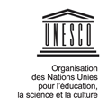
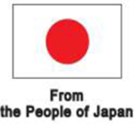
RAPPORT DE FIN DE PROJET
‘’Réponse rapide pour le renforcement des capacités de résilience et à la prévention des conflits dans les régions de l’Extrême-nord et l’Est du Cameroun‘’

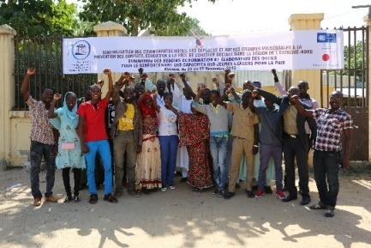

SOMMAIRE

- SOMMAIRE :………………..…………………….…1
- LISTE DES ABREVIATIONS ET ACRONYMES :…....………………………………..2
- CONTEXTE ET JUSTIFICATION DU PROJET :…………………………………………3
- RAPPEL DES OBJECTIFS DU PROJET…………4
- OBJECTIFS SPECIFIQUES DE L’UNESCO…….5
- PRODUITS ATTENDUS
- Produit 1. La réalisation d’une l’étude socio-anthropologique dans les localités cibles du projet pour l’identification de la typologie des conflits, les causes, les acteurs impliqués, les éléments de médiation, mécanismes traditionnels de prévention et de résolution au sein des communautés.
- Produit 2. L’installation d'une plate-forme opérationnelle de jeunes ambassadeurs pour la Paix dans chaque localité.
- Produit 3. Le renforcement des capacités des médias locaux dans le domaine de la culture de la paix et de la prévention des conflits.
- Produit 4. L’appui aux programmes d'installation des plateformes locales de dialogue, de médiation et de résolution des conflits comprenant les autorités, les leaders traditionnels et les communautés locales à Kousseri, Mora et Mokolo.
- Produit 5: campagnes de sensibilisation de masses sont organisées dans les sites de du projet avec une forte implication des communautés et des médias.
- Produit 6. Edition, publication et vulgarisation du Rapport final de l’étude.

LISTE DES ABREVIATION SET DES ACRONYMES

- AGR : activité génératrice de revenus
- FAO : Food and Agriculture Organisation
- MINADER : Ministère de l’agriculture et du développement rural
- MINEPIA : Ministère des pêches et des industries animales
- ONG : Organisation non gouvernementale
- PF : Point Focal
- PNUD : Programme des nations Unies pour le Développement
- UNESCO : Agence des Nations Unies pour l’Education, la Sciences et la Culture
- UNHCR : Haut Commissariat des Nations Unies pour les Réfugiés

I. Contexte et justification du projet
Du fait de la détérioration du contexte humanitaire et sécuritaire dans la Région de l’Extrême-Nord due aux exactions du groupe Boko Haram, le Cameroun fait face à un afflux massif de réfugiés et de personnes déplacées, notamment dans les départements du Logone et Chari (Kousseri), du Mayo Sava (Mora) et du Mayo Tsanaga (Mokolo). De milliers de camerounais ont quitté leurs domiciles et vivent dans des familles d’accueil ou des écoles abandonnées. Dès lors, il est devenu urgent de sécuriser la région et de promouvoir la sécurité des personnes à travers la mise en place d’un cadre de travail pertinent de reconstruction de la paix s’articulant autour de la résilience, l’autonomisation socio-économique des victimes, la prévention des conflits, la promotion de la culture de la paix et le renforcement des capacités institutionnelles pour la coordination et la gestion des risques et du développement.

II. Rappel des objectifs du projet
- Revitaliser les économies locales à travers l’emploi et les infrastructures communautaires à vocation économique ;
- Promouvoir le dialogue intercommunautaire à travers la prévention et la gestion des conflits au sein des communautés de refuge et de retour ;
- Renforcer les capacités digestion, de coordination de l'administration locale et rendre efficaces, fonctionnels et opérationnels les services sociaux de base.

III. Objectifs spécifiques de l’UNESCO
- Identifier les types potentiels de conflits et les personnes concernées dans les localités sites du projet;
- Renforcer les mécanismes opérationnels (existants ou à créer) de dialogue, de prévention et de gestion de conflits ;
- Mettre en place des plateformes opérationnelles de jeunes ambassadeurs de la paix ;
- Renforcer les capacités de l’administration locale, des leaders communautaires et des medias locaux dans le domaine de la culture de la paix et la prévention des conflits ;
- Elaborer un plan de communication et de visibilité autour des activités menées dans le cadre du projet.
IV. Produits attendus
- Produit 1. La réalisation d’une l’étude socio-anthropologique dans les localités cibles du projet pour l’identification de la typologie des conflits, les causes, les acteurs impliqués, les éléments de médiation, mécanismes traditionnels de prévention et de résolution au sein des communautés

1. a. principales réalisations (key achievements)

- Finalisation de l’étude socio-anthropologique dans les localités cible du projet.
Les résultats de cette étude ont notamment permis à l’équipe UNESCO :

- d’acquérir de connaissances pertinentes sur la situation de conflictualité dans les sites du projet ;
- de faire un Inventaire analytique rapide des mécanismes de prévention, de gestion et de résolution des conflits dans la Région de l’Extrême-Nord;
- d’exploiter les données pour l’actualisation des modules de formation des acteurs clés bénéficiaires du projet (jeunes, encadreurs de jeunes, Acteurs des medias, leaders communautaires) sur ma prévention et la gestion/résolution des conflits.

1. b. Contraintes
- Le rapport final de l’étude n’est disponible que depuis le 18 octobre 2015, du fait de la complexité des procédures internes du PNUD dans le recrutement d’un consultant ; et la validation de l’étude le 21 décembre 2015. L’édition et la publication de l’étude ont par conséquent connu un retard.

1. c. Leçons apprises
- Dans la logique de la pérennisation des acquis du projet, les résultats de cette étude constituent une source d’informations pertinentes pour toute stratégie visant à établir ou à renforcer les plateformes locales de dialogue et de médiation existantes ou à créer de concert avec les autorités administratives, les leaders communautaires et les communautés locales.

- Produit 2. L’installation d'une plate-forme opérationnelle de jeunes ambassadeurs pour la Paix dans chaque localité

2. a. Principales réalisations (key achievements)
- L’UNESCO a organisé respectivement :
- du 16 au 19 novembre 2015 à Maroua un atelier d’identification des besoins de formation et d’élaborations d’outils de mobilisation et de sensibilisation communautaire en faveur de 30 jeunes leaders (de Kousseri, Mora et Mokolo) ;
- du 15 au 17 décembre 2015 à Maroua, un atelier sur la prévention et la gestion/résolution des conflits a été organisé au bénéfice de ces 30 jeunes leaders en milieux scolaire et extrascolaire ;
- du 18 au 21 décembre 2015, un atelier de 25 encadreurs de jeunes en milieux scolaire et extrascolaire (Clubs Lycées/collèges ; Centres Multifonctionnels de Promotion de la Jeunesse ; Conseil National de la Jeunesse ; Centres de Promotion de la Femme et de la Famille) pour la mise en œuvre des stratégies et des activités des plateformes des jeunes pour la prévention des conflits et la promotion de la culture de la paix en milieux scolaire et extrascolaire ;
- Des pools de jeunes ambassadeurs pour la Paix issus des différentes structures d’encadrement des jeunes et des communautés ont été constitués au niveau de chaque site du projet à Mokolo, Mora et Kousseri.
Photo : Les jeunes ambassadeurs de la paix en travaux de groupes lors de l’atelier de formation Maroua
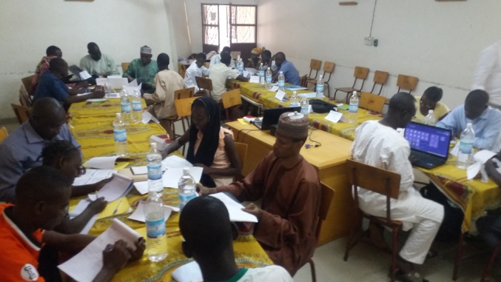

2. b. Contraintes/défis
- L’UNESCO doit accompagner les institutions scolaires et extrascolaires impliquées dans la mise en œuvre des mini-plans d’actions élaborés par les jeunes ambassadeurs de la paix formés pour l’animation des plateformes de dialogue et d’éducation à la paix et à la citoyenneté en milieux scolaire et extrascolaire.
- L’UNESCO et le Ministères partenaires (MINJEC, MINESEC, MINPROFF) doivent réfléchir à des sources de motivation pour soutenir l’émulation et l’engagement des jeunes ambassadeurs de la paix formés à poursuivre leurs activités d‘animation des plateformes de dialogue et d’éducation à la paix après le projet.
2. c. Leçons apprises
- La constitution et l’animation des plateformes de dialogue et d’éducation à la paix en milieu scolaire passe par la redynamisation et la structuration des clubs scolaires (les clubs UNESCO et d’autres clubs pourraient se fondre en clubs d’éducation civique et d’éducation à la paix et se mettre en réseau pour constituer un pool ou plateforme de jeunes ambassadeurs de la paix ;
- L’activisme des jeunes ambassadeurs de la paix de Mora, Mokolo et Kousseri est visible dans les medias sociaux, notamment sur facebook et whatsApp. L’UNESCO canalisera cet engagement des jeunes pour l’éducation et la culture à la paix.
- Le Ministère de la Jeunesse et de l’Education civique sollicite un accompagnement de l’UNESCO dans la poursuite de ses objectifs d’éducation civique et à la citoyenneté des jeunes.

- Produit 3. Le renforcement des capacités des médias locaux dans le domaine de la culture de la paix et de la prévention des conflits

3. a. Principales réalisations (key achievements)
- L’UNESCO a organisé(16- 19 novembre 2015 à Maroua)01 atelier d’identification des besoins et de renforcement des capacités de 20 animateurs/techniciens dans la production et la diffusion des émissions radiophoniques de promotion de la paix et de la coexistence pacifique dans les communautés en langues locales.
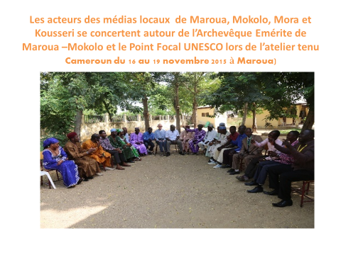

- Des contrats ont été signés avec trois radios de proximité (radio Echos des Montagnes de Mokolo et CRTV radio Maroua et Crtv FM Kousseri) pour la production et la diffusion des émissions sur l’éducation à la paix et à la coexistence pacifique. Ce qui permet la diffusion d’au moins 60 émissions par radio, soit en moyenne 3 émissions /semaine/radio pendant 6 mois. Les genres radiophoniques les plus utilisés sont : les causeries éducatives, les magazines, les interviews, débats, Ces émissions seront utilisées par les jeunes pour l’animation des clubs d’écoute collective en milieux scolaire et extrascolaire ;

- Au début du mois de mars 2016, des radios solaires ont été distribuées aux jeunes ambassadeurs de la paix et à leurs encadreurs pour l’animation des clubs d’écoute collective des émissions éducatives radiodiffusées. Ces clubs d’écoute ont été créés au sein des plateformes de dialogue et d’éducation à la paix mises en place en milieux scolaire et extrascolaire.

3. b. Contraintes
- La radio FM SAVA de Mora connait actuellement des problèmes logistiques et techniques ; ce qui n’a pas permis la contractualisation de ce media par l’UNESCO ;

3. c. Leçons apprises
- Un appui en matériel de pointe des stations radios des zones de couverture du projet est nécessaire pour étendre le rayon et la fréquence de diffusion des émissions;
- Un suivi de proximité des radios locales par l’équipe UNESCO (Secteur Education et Secteur Communication) est indispensable pour évaluer les besoins en formation et logistiques de ces radios sous la coordination de la délégation régionale de la Communication;

Produit 4. L’appui aux programmes d'installation des plateformes locales de dialogue, de médiation et de résolution des conflits comprenant les autorités, les leaders traditionnels et les communautés locales à Kousseri, Mora et Mokolo

4. a. Principales réalisations (key achievements)
Le début du mois de mars (07-10 mars 2016) a été consacré à l’organisation d’un atelier de formation sur le dialogue et la médiation pour la paix destinés aux administrateurs locaux et aux leaders communautaires.
La cartographie régionale des conflits dans l’Extrême-nord montre que des tensions sont enregistrées dans toutes les localités où cohabitent des communautés séparées par l’identité tribale, la religion. L’insécurité constatée dans les départements du Mayo-Sava, Mayo-Tsanaga et Logone et Chari due aux attaques de BokoHaram a provoqué le déplacement massif des populations et réfugiés.La présence durable des populations déplacées et des réfugiés génère une deuxième génération de conflits sociaux dans les localités de Kousseri, Mora et Mokolo, qui se manifestent par le rejet mutuel. Pour pallier ce genre de situations à la fois sources et conséquences de tensions et conflits qui, à court , moyen et long termes affecte et impacte négativement ‘’le vivre ensemble’’ des communautés, qu’il s’avère important d’impliquer les autorités traditionnelles et autres leaders d’opinion dans la recherche et la construction des stratégies de prévention, de médiation et de résolution des conflits. Ils seront essentiellement impliqués dans l’animation des campagnes de masse en vue de la mobilisation sociale de leurs communautés respectives pour la préservation de la coexistence pacifique et la cohésion sociale indispensables pour la reconstruction de la paix et le développement.

4. c. Leçons apprises
- Le CNJ à travers ses antennes décentralisées peut jouer un rôle de mobilisation sociale pour l’organisation des campagnes de mobilisation communautaire sous la coordination technique de la Délégation locale du Ministère de la Jeunesse et de l’éducation civique. La coordination administrative et sécuritaire doit être assurée par les autorités administratives.
- Le CNJ et les Associations et comités locaux de développement doivent travailler en synergie pour la mise en œuvre des stratégies de promotion du dialogue intra et intercommunautaire et de la culture de la paix.

Produit 5: campagnes de sensibilisation de masses sont organisées dans les sites de du projet avec une forte implication des communautés et des médias.

- 5. a. Principales réalisations (key achievements)
03 campagnes de sensibilisation des masses ont été organisées à Kousseri, Mora et Mokolo en présence des autorités administratives, traditionnelles et des diverses leaders opinion des localités concernées.
Pour organiser ces trois campagnes, la stratégie de l’UNESCO s’est articulée autour des principaux points suivants :
- l’Identification et renforcement les capacités des leaders d’opinion et d’associations (les autorités traditionnelles, responsables d’association de développement, responsables départementaux du MINADER et du MINEPIA…) à mobiliser comme personnes ressources lors des différentes campagnes de masse à tenir

- Des outils de sensibilisation ont été soit acquis soit produits (mégaphone, appareils d’animation, des vidéoprojecteurs, des affiches, kakémono, tracts et mis à la disposition de tous les acteurs clés (jeunes ambassadeurs et leurs encadreurs, leaders communautaires) pour la tenue des campagnes de sensibilisation de masse sur les sites retenus.
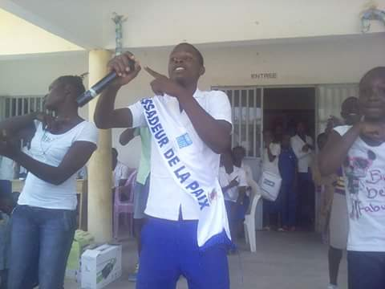
Photo : Les ambassadeurs de la paix en pleine campagne de sensibilisation dans un lycée de MOKOLO.

Produit 6. Edition, publication et vulgarisation du Rapport final de l’étude

6. a. Principale réalisation (key achievement)
L’Etude est éditée et sera publiée et diffusée au sein des associations relais, des autorités et leaders communautaires à des fins d’éducation populaire

V. Coordination, suivi-évaluation des activités à Kousseri, Mora et Mokolo
- Elaboration des indicateurs de suivi pour l’amélioration des formations, des plaidoyers et campagnes de sensibilisation de masse.
- Elaboration des outils de suivi-évaluation des séances d’écoute collective des émissions éducatives sur la culture de la paix et la cohésion pacifique (Fiche d’analyse des rapports mensuels des chefs de stations radios contractualisées.Fiche d’analyse de l’impact sur l’auditoire des émissions; fiches d’analyse de l’impact sur l’auditoire des saynètes /sketches diffusés).
- Rédaction des rapports d’activités.
VI. TABLEAU DE PROGRES DES INDICATEURS
Produit/livrable | Localité | Partenaire | Niveau d'atteinte à date | (%) d’atteinte à date | Observations
Réalisation d’une étude socio anthropologique sur la prévention et la gestion des conflits | Mokolo  Kousseri  Mora | PNUD/  Consultants | Mise à disposition de rapport de l’étude le 18 octobre 2015 et validation de l’étude le 21 décembre 2015 à Maroua | 90% | l’édition et la publication de ladite étude est projetée par l’UNESCO
L’installation d'une plateforme opérationnelle de jeunes ambassadeurs pour la Paix dans chaque localité | Mokolo  Kousseri  Mora | MINJEC  MINESEC  MINPROFF | - les participants (jeunes et adultes) des collèges/lycées ; CNJ, CMPJ et CPFF des sites d’intervention du projet ont été initiés aux stratégies et activités d’animation des plateformes de jeunes pour la prévention, la médiation et la résolution pacifique des conflits en milieux scolaire et extrascolaire.  - Des pools de jeunes ambassadeurs pour la Paix issus des différentes structures d’encadrement des jeunes et des communautés sont constitués au niveau de chaque site du projet à Mokolo, Mora et Kousseri | 90% | - Des mini- plans d’actions sont élaborés et les clubs ont commencé les séances d’animation sur la culture de la paix et la coexistence pacifique.  -L’activisme des jeunes ambassadeurs de la paix de Mora, Mokolo et Kousseri est visible dans les medias sociaux, notamment sur face book et Twitter. L’UNESCO canalisera cet engagement des jeunes pour l’éducation à la paix.
Renforcement des capacités médias locaux dans le domaine de la culture de la paix et de la prévention des conflits | MarouaMokolo  Kouseri  Mora | PNUD  FAO  DR/MINCOM | Un (01) atelier de renforcement des capacités des 20 acteurs des medias locaux (CRTV, FM SAVA, FM KOUSSERI et RADIO ECHOS DESMONTAGNES (Mokolo) s’est tenu à Maroua du 20 au 22 novembre 2015  Des émissions radiophoniques de promotion de la culture de la paix et de la coexistence pacifique sont produites et diffusées par ces radios dans les communautés en langues locales (fufuldé, arabe Choas, | 80% | La contractualisation récente des 03 radios (CRTV, FM KOUSSERI et RADIO ECHOS DESMONTAGNES permettra la diffusion de 2 semaines /semaine/radio pendant 6 mois.
Appui aux programmes d'installation des plateformes locales de dialogue, de médiation et de résolution des conflits comprenant les autorités, les leaders traditionnels et les communautés locales | Maroua,  Mokolo,  Mora, Kouseri | PNUD  FAO  OBC | Des kits de sensibilisation (mégaphones, postes radios solaires, enregistreurs, appareils photos numériques) sont acquis et mis à la disposition les jeunes ambassadeurs de la paix en milieux scolaire et extrascolaire pendant les périodes des congés et lors des grands évènements socio-communautaires ; | 70% | Des activités d’animation péri et postscolaires sont organisées par les plateformes de jeunes et les associations communautaires(antennes communales et départementales du CNJ, comités de développement …) dans les sites du projet depuis le mois de janvier 2015
organisation de 03 campagnes de masses dans les sites de du projet avec une forte implication des communautés et des médias. |  |  | 03 campagnes de sensibilisations ont été organisées à Kousseri, Mora et Mokolo au cours de la période du 12 au16 mars 2002 |  | Des outils de sensibilisation ont été soit acquis soit produits (mégaphone, appareils d’animation, des vidéoprojecteurs, des affiches, kakémono, tracts et mis à la disposition de tous les acteurs clés (jeunes ambassadeurs et leurs encadreurs, leaders communautaires) pour la tenue des campagnes de sensibilisation de masse sur les sites retenus.
Renforcement des capacités des autorités et des leaders locaux dans le domaine de la prévention/  gestion/  résolution des conflits | Mokolo  Kousseri  Mora | PNUD  FAO, MINADER  MINEPIA |  | 80% | - Les modules de l’atelier de renforcement de capacités  Ont été finalisés avec les résultats de l’étude socio-anthropologique  et un atelier a été organisé du 07 au 09 mars 2016 en faveur des autorités et des leaders communautaires  -D’autres besoins de formations ont été identifiés en collaboration avec les bénéficiaires
Coordination suivi-évaluation des activités | Mokolo  Kouseri  Mora | PNUD  FAO | Elaboration des indicateurs de suivi pour l’amélioration des formations, des plaidoyers et campagnes de sensibilisation de masse.  Elaboration des outils de suivi-évaluation des séances d’écoute collective des émissions éducatives sur la culture de la paix et la cohésion pacifique (Fiche d’analyse des rapports mensuels des chefs de stations radios contractualisées. Rédaction des rapports d’activités. | 100% | - Des rapports sont faits au point focal UNESCO par les responsables des pools de jeunes ambassadeurs de la paix  - Des outils de suivi-évaluation des comportements en faveur de la culture de la paix et la coexistence pacifique sont élaborés (Fiches d’analyse des rapports mensuels des chefs de stations radios et fiches d’analyse de l’impact des émissions sur l’auditoire ont été élaborés.  - Les rapports des activités du volet UNESCO sont disponibles et partagées  - Des missions de suivi-évaluation sur le terrain sont organisées par l’équipe UNESCO depuis le début mois de Février 2016
VII. ANALYSE DES ECARTS OBSERVES DANS LES PROGRES DES INDICATEURS
- Très peu de leaders communautaires femmes ont été formés, du fait du refus de leurs conjoints de les laisser aller en formation hors des sites de réfugiés
- Du fait de problèmes logistiques internes la radio SAVA FM a été inopérationnelle au cours de l’exécution du projet.
- La quantité de radios solaires achetées a été insuffisante pour couvrir les besoins de tous les clubs d’écoute à mettre en place dans les espaces de cohésion des femmes et les structures de dialogue (chefferies, cases communautaires etc.) hors sites.
- La précarité des moyens des personnels qui se déploient dans un environnement très difficile constitue une difficulté réelle pour l’atteinte des objectifs du projet.
VIII. GESTION FINANCIERE
Un rapport détaillé de la gestion financière du volet UNESCO est en préparation et sera adressé au PNUD à toutes fins utiles.
Toutefois, il est important de noter qu’en considérant toutes les activités à réaliser dans le volet confié à l’UNESCO, le taux de consommation des fonds au 31 Mars 2016 se situe à plus de 95% sans compter les frais de gestion.
IX. BONNES PRATIQUES
La communication sur les activités et la participation des agences aux activités des unes et des autres améliorent la visibilité du projet et permet une meilleure capitalisation conjointe des acquis.
L’UNESCO a exploité toutes les plateformes de dialogue existant dans les communautés cibles du projet pour ses activités de communication pour le changement de comportement. Dans cette logique, les clubs scolaires ont été exploitées par l’UNESCO pour la mise en œuvre des activités des «groupes/clubs d’écoute collective» des émissions radio-éducatives sur la prévention, la gestion/la résolution des conflits, la culture de la paix et la cohésion sociale.
La mise à la disposition des animateurs des clubs d’écoute des supports amovibles de stockage des émissions (Clés USB) est un gage de pérennisation des activités d’animation des activités des clubs d’écoute.
Avec des équipements mis à leur disposition, les plateformes créées au sein des clubs scolaires et en milieu extrascolaire sont à la fois des espaces de loisirs sains incluant la projection des films, l’organisation de vidéo-débats …ouverts à toutes les tranches de jeunes , en plus d’être des espaces d’éducation, d’écoute et de conseil .
Par ailleurs, un suivi de proximité des radios locales est indispensable pour évaluer les besoins en formation et logistiques de ces radios

CONCLUSION
Pour capitaliser les acquis du projet en termes de volume d’activités et d’impact, les sessions de formation et de renforcement des capacités sur l’éducation à la paix et la cohésion sociale doivent s’étendre aux jeunes et aux encadreurs de jeunes de toutes les structures d’enseignement primaire des sites du projet y compris autour du site des réfugiés de MINAWAO ( Mayo Tsanaga).
L’équipe de l’UNESCO doit assurer un suivi personnalisé des pools de jeunes scolaires et extrascolaires sur chaque site en fonction de la diversité des contextes et du dynamisme de chaque pool de jeunes.
La représentation régionale du Conseil national de la jeunesse (CNJ) dans l’Extrême-Nord et ses antennes locales (départementales et communales) peuvent constituer certes une certaine force de mobilisation de jeunes en milieu extrascolaire, mais leur fonctionnement actuel n’a pas encore acquis la confiance de la plupart d’associations de jeunes agréées ou reconnues par le Ministère de la Jeunesse et de l’Éducation civique.

Au total, la mise en œuvre des activités du volet confié à l’UNESCO a accusé du retard pour une raison principale: la sélection et la contractualisation du consultant en charge de l’étude socio-anthropologique dont les résultats étaient indispensables pour une mise en œuvre efficace des stratégies de l’UNESCO ont pris plus de temps que prévu dans les procédures de validation au niveau du PNUD.
Toutefois, avant la fin du mois de décembre 2015 ce retard a été rattrapé : les modules de formation des diverses cibles ont été finalisés ; les ateliers de renforcement des capacités ont été organisés au bénéfice des différents acteurs clés et les outils de mobilisation et sensibilisation communautaires ont été élaborés et diffusés au sein des diverses structures/plateformes de dialogue, de prévention et de gestion des conflits en milieux scolaire, extrascolaire et communautaire.
Dès la fin du mois de février 2016 des missions de suivi-évaluation sur le terrain ont été organisées par l’équipe UNESCO.

En outre, l’UNESCO a assuré la gestion de la communication du projet dont l’objectif principal est de contribuer à l’effort de mobilisation des agences des Nations Unies, sous la coordination du PNUD, pour amorcer le relèvement précoce dans les localités ciblées et renforcer la résilience et la prévention des conflits. Cela s’est décliné en activités et produits de communication ayant pour but d’accroitre la visibilité sur ce projet humanitaire, ainsi que celle du donateur, conformément au document du projet.
Dans cette logique, un plan de communication a été élaboré et mis en œuvre pour accroitre la visibilité du projet et celle des principaux acteurs impliqués.
Annexe 3

RAPPORT GENERAL DE L’ATELIER D’EVALUATION PARTICIPATIVE AVEC LES ACTEURS CLEFS DU PROJET RAPID RESPONSE TENU A MAROUA LE 22 AVRIL 2016
L’an 2016 et le vingt-deux (22) du mois d’avril, s’est tenu à Maroua dans la salle des conférences de la Caisse Nationale de Prévoyance Sociale (CNPS) l’Atelier d’Evaluation des Acteurs Clefs du projet Rapid Response. Cet atelier, organisé par le sous-bureau du Programme des Nations Unies pour le Développement (PNUD) pour l’Est et l’Extrême-Nord, a réuni plusieurs acteurs impliqués et concernés par ce projet. Outre, les cadres du PNUD, les Préfets, les Sous-Préfets des départements du Mayo-Sava, du Mayo-Tsanaga et du Logone et Chari ou leurs représentants, ont pris part à cet atelier les délégués départementaux des mêmes circonscriptions administratives, des ministères de l’agriculture, de l’environnement, de la protection de la nature et du développement durable, de l’élevage, les chefs des postes agricoles, les responsables de plusieurs organisations de la société civile de l’Extrême-Nord, du Fonds National de l’Emploi (FNE), les responsables des Groupements d’initiative Commune (GIC) et quelques bénéficiaires directs du projet.
L’atelier en lui-même s’est déroulé en plusieurs phases, à savoir l’ouverture, la présentation du contexte de son organisation, la présentation des résultats/réalisations du projet dans les différentes zones d’intervention, les échanges et discussions autour de la présentation des résultats, suivis de l’évaluation des effets générés par le projet, les forces, les faiblesses, les défis, les insuffisances et les leçons apprises du projet, puis les témoignages des bénéficiaires, des acteurs impliqués et leurs recommandations, et enfin la clôture.
Pour ce qui des travaux proprement dits, ils ont débuté autour de 9h30 min avec l’introduction du modérateur ENOKA, enseignant à l’Ecole Normale Supérieure de Maroua qui, après avoir souhaité la bienvenue aux participants, a situé le contexte de la tenue de l’atelier, tout en déroulant ses différentes articulations telles qu’évoquées plus haut. Avant de passer la parole aux présentateurs des résultats du projet, Charles EDOA du PNUD et Jean BIYONG de la FA0, c’est Cyprien GAGNON, chef du Sous-bureau du PNUD qui a brièvement intervenu, en relevant que le projet Rapid Response mis en place il y a douze (12) mois, soit une année entière, voudrait mettre autour d’une table les différents acteurs impliqués, pour voir ce qui a été fait, les perceptions des uns et des autres sur le projet, leurs impressions sur ce qui a marché et ce qui n’a pas marché, en vue d’une amélioration dans le cadre des appuis à venir.
La présentation de M. Charles EDOA s’est appesanti sur deux éléments : la présentation du projet Rapid Response à travers le contexte et la justification, ses objectifs, ses zones d’intervention, ses bailleurs de fonds, les activités planifiées/cibles d’une part et les activités réalisées et les cibles atteintes d’autre part. Cette présentation très vivante sur powerpoint, a eu le mérite d’édifier le public, images et chiffres à l’appui de ce qui était prévu, ce qui a été effectivement réalisé, qu’il s’agisse des activités génératrices des revenus (agriculture, élevage), des mécanismes de prévention des conflits (plates-formes de gestion des couloirs de transhumance ou construction des parcs vaccinogènes et des marchés à bétail) ou de la gestion des risques et catastrophes (élaboration des plans ORSEC). C’est Jean BIYONG de la FAO qui emboîtera le pas à Charles EDOA, pour davantage axer son intervention sur les résultats atteints par le projet. Sa démarche semblable à celle de son collègue, a permis de rendre davantage compte des résultats atteints. Cet exposé a eu le mérite de présenter zone par zone les appuis apportés, images et statistiques à l’appui (des semences distribuées, des porcs, de la volaille, des ovins, des foyers améliorés, des marchés à bétail, des parcs vaccinogènes, etc). Ces deux exposés ont été suivis par des échanges et discussions. La méthode de travail adoptée, a été celle de prendre une série de trois questions, et de passer la parole aux présentateurs et d’autres responsables du projet présents dans la salle pour les réponses.
C’est MAHAMAT BAAR de l’association camerounaise pour le dialogue interreligieux (ACADIR) qui inaugure cette phase, en remerciant très sincèrement les présentateurs et le PNUD pour les actions si nombreuses réalisées. Sa préoccupation était relative au fait que les présentateurs aient mentionné la construction des parcs vaccinogènes comme facteurs de prévention des conflits. Cela lui paraissait flou et impertinent. Le délégué département de l’environnement, de la protection de la nature et du développement durable du Mayo-Sava prendra également la parole, pour demander si la présentation de Charles EDOA et Jean BIYONG, renvoyait aux résultats atteints ou plutôt aux appuis apportés. Pour lui, les exposés ont présentés les résultats de façon absolue, alors qu’ils auraient pu l’être plutôt de façon relative. Et son collègue du Mayo-Tsanaga remettra à jour la question de MAHAMAT BAAR, pour savoir en quoi les parcs vaccinogènes contribuent-ils à la résolution des conflits ?
En guise de réponses, Charles EDOA a relevé que la présentation faite n’était pas suffisamment détaillée, compte tenu du temps imparti, mais qu’à l’intérieur du document élaboré, tous les détails s’y retrouvent. Et Cyprien CAGNON a précisé que c’est sur le document de listing des besoins des réfugiés et des personnes déplacées élaboré par le HCR, que le PNUD et la FAO se sont appuyés, étant donné qu’en dehors des besoins et eau et en nourriture, un accent avait été mis dans ledit document sur la nécessité de promouvoir les activités génératrices de revenus auprès de ces populations.
La seconde série de questions a été inaugurée par le délégué département de l’environnement et de la protection de la nature et du développement durable du Logone et Chari. Il est revenu sur la difficulté à comprendre si la présentation faite par Charles et Jean relevait des résultats, ou constituaient tout simplement l’inventaire des réalisations. Mme AICHA MOUSSA de l’UICN quant à elle, a pris la parole pour remercier le PNUD pour la densité et la qualité de ce qui a été fait un en temps record, c’est-à-dire un an. En saluant la distribution de foyers améliorés qui constituent, selon elle, une excellente mesure de lutte contre la destruction de l’environnement, elle a voulu savoir si des mesures ont été prises pour vérifier l’usage effectif de ceux-ci par les bénéficiaires. MAMOUDOU ISSA de la délégation régionale de l’environnement et de la protection de la nature et du développement durable pour l’Extrême-Nord, a pur sa part formulé la critique selon laquelle la présentation a péché par le fait que l’Est et l’Extrême-Nord ont été abordés en même temps, alors qu’elle aurait gagné en se focalisant uniquement sur l’Extrême-Nord, étant donné que les participants à l’atelier ne se recrutent qu’au sein de cette régions.
Outre les précisions apportées par Charles EDOA, Jean BIYONG et Cyprien GAGNON, les réponses à cette série ont permis à tous de savoir que les foyers sont bel et bien utilisés et à bon escient, et qu’il existe d’ailleurs un plan de suivi de l’ensemble de ces réalisations. Ce plan implique les délégués départementaux, les chefs de poste d’agriculture et d’élevage, qui pourraient d’ailleurs apporter des témoignages.
La troisième série des questions a été surtout axée sur les critères de sélection des bénéficiaires, le contrôle des semences distribuées, la question de la pérennisation du projet, en cherchant à savoir si un dispositif destiné à autonomiser les bénéficiaires a été pensé. C’est Joséphine FIMANOU du FNE qui a formulé ces préoccupations. Charles EDOA a répondu en relevant que les critères de sélection proposés par le projet, ont été fortement renforcés par les propositions des sectorielles. Et pour ce qui est des mécanismes de pérennisation, de nombreux bénéficiaires à l’Est sont par exemple devenus aujourd’hui de véritables producteurs et les activités marchent à merveille. Des familles bénéficiaires de l’aviculture sont également à plus cinq livraisons aujourd’hui, devenant ainsi de véritables entrepreneurs dans ce domaine. Jean BIYONG a complété en mentionnant les résultats qu’ont donnés les semences d’oignons, de laitues, de choux et de carottes améliorés distribués, et les mises bas des ruminants distribuées dans le Mayo-Tsanaga.
Pour ce qui concerne le contrôle des semences, il a relevé qu’elles ont été acquises auprès de l’Institut de recherche Agricole (IRAD) dont l’expertise en la matière ne fait aucun doute. Des tests préalables payés par la FAO ont été faits. Cyprien GAGNON a tenu à mentionner que, compte tenu de l’immensité des besoins sur le terrain, les réunions répétés avec les délégués départementaux et d’arrondissement pour évaluer les vulnérabilités, ont permis de retenir environ dix (10) critères qui ont été discutés et convenus. Au sujet de la pérennisation des appuis, il a tenu à préciser que les délégués et les autres fonctionnaires qui accompagnent le projet, ont un grand rôle à jouer, de même que les bénéficiaires eux-mêmes.
Le représentant de la délégation de l’environnement, de la protection de la nature et du développement durable, a suggéré l’idée de l’utilisation des pompes solaires, posé le problème de la formation des bénéficiaires, des surfaces et des quantités de semences distribuées. A ces questions, Charles EDOA a tenu à préciser qu’en ce qui concerne les surfaces, elles ont été estimées à 100m2 par ménage. Quant à la formation, elle est permanente et concerne aussi bien les bénéficiaires, les responsables en charge du suivi, que les prestataires. Quant aux pompes solaires, le projet enregistre la suggestion et verra dans quelle mesure elle pourrait être expérimentée. Une autre préoccupation importante a été relevée par ABOUBAKAR de la délégation régionale du ministère de la jeunesse, et était relative à l’évaluation des résultats de la formation et de l’action des ambassadeurs de la paix. En guise de réponse, les responsables du projet ont convenu avec lui de la difficulté de mesurer ce qui a été effectivement fait, mais ont tenu tout de même à relever que le nombre des lycées et des personnes sensibilisées, constituent déjà des indicateurs pertinents. Des estimations peuvent être faites à partir du nombre de personnes mobilisées à tel ou tel endroit, à telle ou telle circonstance. C’est sur ces aspects que cette première phase d’échanges et de discussions s’est refermée, pour reprendre autour de 11h20 min après la pause-café, avec les témoignages des différents délégués présents, en charge du suivi rapproché du projet sur le terrain.
Le délégué départemental de l’élevage du Mayo-Sava, a pris la parole pour présenter les réalisations concrètes du projet sur le terrain, à savoir 25 bénéficiaires en petits ruminants et 40 en poulets locaux. Dans le village de Kossa, 13 personnes ont bénéficié des poulets locaux, 08 des petits ruminants (même comme deux bénéficiaires, Mme Djidja et Bouka Moulloum, qui étaient des déplacés, ont rejoint leurs villages d’origine). On a enregistré 06 mises bas tandis qu’un bénéficiaire a été victime d’un coup de vol (Sanda Djeffef). Les poulets de Kossa ont déjà des poussins. A Mémé, il y a eu également 06 mises bas, tandis qu’à Seradoumda, les bénéficiaires ont perdu la totalité des poulets locaux octroyés. Heureusement qu’ils ont été remplacés par le projet. A Mora-Ville, il y a eu 06 mises bas, mais les bénéficiaires de la volaille ont également perdu tous leurs sujets. Ce qui fait un total de 15 mises bas. En termes de faiblesses, il a relevé ce qui suit :
1) Le fait que l’acquisition des sujets soit effectué par des fournisseurs qui n’ont aucune connaissance en la matière d’élevage, est déplorable. Des poulets malades ou infectés ont ainsi été remis aux bénéficiaires, d’où la contamination et la mort de plusieurs autres qui étaient sains ;
- La construction des poulaillers et bergeries ne respecte aucune norme définie par le projet ;
- Le remplacement des sujets morts n’a pas couvert l’ensemble des le zone du projet, d’où la frustration et l’inquiétude de certains bénéficiaires ;
- Au niveau de la construction du marché à bétail qui s’est très bien faite, il subsiste quelques problèmes, notamment la présence des abreuvoirs alors qu’il n’existe pas de points d’eau. Il en est de même de l’absence des latrines/toilettes, vivement réclamées par les éleveurs et commerçants de bétail.

Le délégué départemental d’élevage du Mayo-Tsanaga quant à lui, a mentionné qu’au départ du projet, 06 ménages de Gawar ont bénéficié de 18 petits ruminants et 10 autres ménages en volaille, soit 100 sujets distribués. A Mokolo-centre, 11 ménages ont reçu des petits ruminants (03 par ménage, dont 01 mâle et 02 femelles), pour un total de 33 chèvres. 18 ménages ont également reçu de la volaille, dont 10 sujets par ménage pour un total de 180 poulets. Comme incidents, 12 bénéficiaires ont perdu tous leurs sujets et c’est ainsi qu’ils ont été regroupés, soit 02 groupes comprenant deux personnes chacun. Présentement, les 11 ménages bénéficiaires ont enregistré 03 mises bas, tandis que les 02 nouveaux groupes en ont enregistré 05 ; 03 autres bénéficiaires ont vendu leurs volailles et les ont remplacées par des chèvres. Les 03 ménages pour volaille, comprennent respectivement 03 poules et 13 poussins, 02 poules et 08 poussins et 02 poules et 08 poussins, puis 03 poules et 16 poussins. A Zamay, on a enregistré dès le départ 06 ménages qui ont reçu 03 têtes de petits ruminants chacun (01 mâle et 02 femelles), pour un total de 18 chèvres. 12 ménages ont bénéficié de 10 volailles villageoises chacun, pour un total de 120 sujets. Compte tenu du fait que tous les bénéficiaires avaient perdu leurs sujets, le PNUD a procédé à leur regroupement, en leur donnant à nouveau un appui en chèvres (10 chèvres, soit 03 mâles et 07 femelles) et de la volaille. Présentement, 06 ménages ont enregistré 02 mises bas, 04 chèvres sont en gestation, tandis qu’un groupement de 12 ménages a plutôt enregistré 03 mises bas et 04 chèvres sont en gestation. Pour ce qui est des remarques, il les a articulées de la manière suivante :
- Le peu d’implication des services sectoriels dans l’acquisition des animaux et à l’achat des intrants animaux. Cette implication aurait permis de faire des bons choix, plutôt que de laisser les fournisseurs s’en occuper tous seuls ;
- Il se pose un grand problème de suivi sanitaire des animaux, d’où la suggestion de confier ce volet aux services techniques d’élévage, qui ont non seulement les compétences, mais également la volonté de travailler ;
- Le peu d’implication du PNUD dans la prise en charge du personnel des services sectoriels, impacte forcément sur leur degré d’engagement, puisqu’ils ne se sentent pas tenus par une quelconque obligation des résultats.

Le délégué départemental de l’élevage du Mayo-Sava, a salué la construction du marché à bétail de Mora, qui fonctionne normalement depuis trois semaines, avec un engouement réel des vendeurs et des acheteurs. Comme limites, il a relevé l’existence des abreuvoirs construits, mais qu’il n’existe pas de points d’eau pour les rendre viables, ainsi que les latrines.
Celui du Logone et Chari a fait des témoignages détaillés en mentionnant que la réhabilitation du marché de bétail de Kousséri(IBOU) qui vient d’être réalisé dans le cadre du projet Rapid Response, fait de lui le plus grand de la région de l’Extrême-Nord aujourd’hui. S’étendant sur une superficie de 40 000m2, il bénéficié d’une clôture entièrement construite avec une guérite, un forage, des latrines et surtout les magasins. Il est de plus en plus fréquenté avec environ 500 à 550 têtes de bovins et se tient deux fois par semaine (mardi et samedi). Une projection des images de cet impressionnant marché flambant neuf a été d’ailleurs faite, et les participants à l’atelier ont pu prendre la mesure de la qualité et la densité des investissements réalisés. Le délégué a également tenu à mentionner que près de 450 personnes ont été touchées par les petits ruminants et 40 familles des poulets villageois.
Pour ce qui concerne les délégués d’agriculture et du développement rural, celui du Mayo-Tsanaga s’est appesanti dans son intervention sur appuis apportés par le projet. Dans cette perspective, il a fait mention de la distribution des intrants agricoles, notamment les semences des cultures de contre saison à 300 ménages (du département et les réfugiés). Ces intrants étaient composés des semences de laitues, de betteraves, de choux, de tomates, de carottes, de poivrons, d’oignons, persils, accompagnés des produits comme l’azote et l’Ivpp. Les récoltes qui ont suivi, ont été abondantes et de très bonne qualité, selon les témoignages de bénéficiaires. Des unités de transformation des céréales à sec ou humide (moulins) ont été octroyés à 03 groupements, et les inspections sur le terrain montrent que tout marche bien dans l’ensemble. Ces unités ont considérablement soulagé les femmes de plusieurs villages, qui étaient obligées par le passé de parcourir des dizaines de kilomètres pour écraser les céréales. Pour ce qui est des recommandations, il a été suggéré que les prestataires des unités de transformation soient sélectionnés au niveau local, c’est-à-dire dans les zones où vivent les bénéficiaires, étant donné qu’une fois les unités installées, des problèmes d’accessoires et de petites pannes subsistent et il n’est plus facile de mettre rapidement la main sur ces prestataires.
Dans le Mayo-Sava, l’appui dans le domaine agricole a touché 250 bénéficiaires constitués des populations locales et des déplacés, et ont couvert 06 bassins de production, à savoir Mora, Kourgui, Kossa, Seradoumda, Malika et Aïssa-Hardé. Il s’est agit des semences d’oignons, d’oseille de Guinée, des tomates, des laitues et des fertilisants tels que l’engrais NPK et l’urée. Pour ce qui est du suivi, un accompagnement de proximité a été assuré par les agents de vulgarisation agricole (AVZ) dans bassins et localités concernés. Cet accompagnement est basé sur les formations des bénéficiaires sur les modules tels que les itinéraires techniques, les appuis-conseils, les modules sur la gestion. Ces formations se sont faites avec succès et les témoignages des bénéficiaires à ce sujet sont édifiants. Ces appuis ont ainsi permis de faire un gain en temps (30 jours au lieu de 40, voire plus pour plusieurs nouvelles variétés de semences), la croissance rapide des champs et une forte capacité de résistance aux maladies et aux insectes. En termes de difficultés rencontrées, il y a le problème d’eau qui a été signalé par certains, dû à la mise en place tardive des cultures ; les faibles quantités de semences reçues par certains bénéficiaires et le problème de prise en charge des encadreurs en termes de carburant et de motivation. Il est nécessaire de revoir les périodes de mise en place de semences, pour éviter les retards et penser à encourager les encadreurs sur le terrain.
Le délégué d’agriculture du Logone et Chari, quant à lui, a également mentionné les mêmes appuis que ses collègues. Il ressort de son propos que 250 paysans ont reçus des semences, des pulvérisateurs, de l’engrais et de l’urée. Selon les témoignages des bénéficiaires et des encadreurs, les semences distribuées sont d’excellente qualité, avec des résultats encourageants en termes de production.
Pour ce qui est de l’environnement, le délégué du Mayo-Tsanaga a, dans ses propos, tenu à présenter les activités menées. Il ressort de sa prise de parole qu’en amont de la distribution des foyers améliorés, un recensement préalable de plus de 2500 ménages par sa délégation, en collaboration avec les chefs des quartiers, avait été fait. La distribution des foyers en question a été faite par les responsables du PNUD et de la FAO, en présence des chefs des quartiers et villages, de l’administration et de la délégation du ministère de l’environnement et de la protection de la nature et du développement durable. Les descentes sur le terrain ont permis de se rendre compte de l’effectivité de l’utilisation de ces outils par les bénéficiaires et d’ailleurs, une mission de la Fao a permis également de s’en rendre compte.
Dans le Mayo-Sava, 500 foyers améliorés ont été effectivement distribués à 495 femmes chefs de ménage déplacés, et 05 hommes chefs de ménages déplacés en également bénéficié, sur un total de plus de 2000 personnes recensées. Les bénéficiaires sont originaires de 09 localités de l’arrondissement de Mora. Les foyers en question sont une technologie nouvelle d’efficacité énergétique évidente introduite auprès de populations traumatisées par la guerre. Il est donc nécessaire qu’un bon suivi post-distribution soit assuré auprès des bénéficiaires, pour assurer et garantir l’atteinte des objectifs escomptés. En marge de la distribution, le délégué a relevé que les avantages des foyers améliorés sont nombreux :
- Sur le plan économique, ces foyers permettent un réel gain en termes de temps de recherche du bois de chauffe par les femmes ;
- Sur le plan financier, ils permettent de faire un gain d’environ 70 FCFA pour la cuisson, économie sur le coût du bois de chauffe utilisé ;
- Sur le plan environnemental, les foyers améliorés permettent de réduire d’au moins 30% la quantité de bois de chauffe utilisé pour la cuisson, d’où la réduction de la coupe de bois dans les espaces naturels environnants ;
- Sur le plan sanitaire, les foyers améliorés permettent de dégager moins de fumée et de saletés, d’ où la préservation de la santé des femmes.

Dans le Logone et Chari, le délégué a rappelé qu’avant, très peu de ménages utilisaient les foyers améliorés (05 à 06 ménages seulement), alors qu’ils avaient été distribués. Est-ce que les gens les envoyaient à leurs frères du côté du Tchad, plutôt que de les utiliser sur place ? L’avènement du projet a permis de distribuer 500 foyers dans 03 arrondissements (Kousséri, Fotokol et Makary). Toutes les familles bénéficiaires sont celles des déplacés et des familles d’accueil. La distribution s’est faite pendant trois jours durant, en présence des responsables de la FAO, avec démonstration à l’appui à l’intention des bénéficiaires. Des descentes sur le terrain ont permis de constater un réel engouement dans l’utilisation de ces foyers, engouement dû peut-être au fait que le ministère de l’environnement avait pris l’habitude depuis quelques années, de distribuer des foyers.

Après les témoignages et suggestions des délégués, ce sont quelques bénéficiaires présents à la rencontre qui sont passés livrer les leurs, pour dire en quoi le projet a changé leurs conditions de travail et amélioré leurs conditions de vie. Cette phase a débuté lorsqu’il était 13h45 min, après la pause déjeuner. Outre les témoignages des bénéficiaires présents à l’atelier (05 témoignages), l’on a également enregistré ceux des autorités administratives et des délégués encadreurs du projet sur le terrain.
Concernant les bénéficiaires, c’est Mme Béatrice MATASSI de Mandaka (Mokolo) qui a témoigné de la réception d’une unité de transformation. Il ressort de son témoignage qu’avant l’implantation de cette unité, les femmes/enfants étaient obligées de parcourir des dizaines de kilomètres pour écraser les céréales, avec tout ce que cela exige en temps et les risques possibles, dans un contexte où Boko Haram ne cesse de faire des victimes. L’unité de transformation a apporté un réel souffle dans la localité, d’où la satisfaction et les remerciements de tous à l’endroit du projet. Elle a terminé son propos en posant le problème des accessoires du moulin qui perturbe son fonctionnement, et a formulé le vœu de voir le projet y apporter des solutions durables.
NGOYA DEGUIME, agriculteur du village Mandaka (Mokolo) et spécialisé dans le maraîcher, a également apporté des éclairages sur ce qu’il a bénéficié du projet dans l’exercice de ses activités (semences de choux, de betteraves, de persils, de poivrons, de tomates, de laitues). Avant, il était difficile d’en acquérir facilement et rapidement, étant donné qu’il fallait se déplacer plusieurs fois sur Maroua ou Garoua pour en acquérir. Ce qui a considérablement amélioré sa production, avec des rentrées financières importantes pour le grand soulagement de sa famille.
Jonas, chef de poste agricole de Kossa, a noté une mobilisation sans précédent des groupements par le projet. Ce qui a incité beaucoup de personnes à travailler avec engouement. Les groupements sont en passe de moderniser leur gestion avec l’ouverture des comptes d’épargne ; ils font le stockage des céréales pour les revendre pendant la période de soudure (20 sacs de sorgho et 10 sans de niébé) espérant des bénéfices plus conséquents. Les groupements non bénéficiaires sont également motivés de plus en plus, dans l’espoir d’être les prochains bénéficiaires. Il a terminé son témoignage en invitant le projet à penser à implanter prochainement les unités de transformation dans d’autres zones reculées, où les femmes continuent à payer le lourd tribut des distances.
ABBA KATKOTE du village Seradoumda (Mayo-Sava), agriculteur spécialisé dans la production des oignons, a mentionné qu’avant l’avènement du projet, les semences étaient médiocres. Ce qui ne permettait pas d’avoir de bons rendements. Il était difficile d’avoir 10 sacs pour une surface de 150 carreaux. La moisson tournait autour de 06 sacs tout au plus. Mais avec la variété distribuée par le PNUD, il a obtenu 12 sacs, avec des produits de qualité excellente. N’eut été l’épreuve du manque d’eau auquel il a fait face, il aurait récolté un minimum de 15 sacs. La variété en question est précoce et moins difficile à conserver, comparativement à l’espèce locale. Présentement, beaucoup de paysans ont formulé la demande d’obtenir en grande quantité ces semences pour la prochaine campagne. Il a relevé comme handicap, le fait que la quantité des intrants n’était pas proportionnelle aux semences distribuées. Et l’une des doléances fortes qu’il a formulées, c’est le vœu de la construction d’un magasin de conservation des oignons dans la zone, qui donnera un grand souffle aux paysans, obligés de vendre très moins chers leurs oignons, à cause de la difficulté de le stocker et de le conserver.
Toujours dans la mouvance des témoignages, Mme le délégué du commerce du Mayo-Tsanaga a entretenu l’assistance sur ce qui a été réalisé, tout en transmettant les sincères remerciements des populations bénéficiaires au PNUD. Concrètement, elle a fait mention de la rénovation du marché agropastoral de Lauraï. Il s’est agit de la construction d’un parc à bétail, d’un hangar en matériaux définitifs et de la réhabilitation d’un local construit il y’ a quelques années par le Projet d’Amélioration du Revenu Familial (PARFAR) au sein de ce marché. Les populations bénéficiaires se recrutent tant au sein des populations que parmi les déplacés et les réfugiés. En collaboration avec le Lamido de cette localité, un comité de gestion a été mis sur pied. L’autorité administration, en l’occurrence le Sous-préfet de l’arrondissement de Mokolo, n’a ménagé aucun effort pour faire comprendre aux populations la nécessité de pérenniser cet acquis, à travers un entretien optimal. Elle a également mentionné quelques doléances formulées par les populations, notamment la construction des magasins de stockage des céréales pour permettre de relativiser le coût du transport des produits invendus des marchés vers les domiciles, où leurs greniers sont à la merci des destructions du fait de l’incursion des membres de la secte Boko Haram. Elle a pour sa part émis aussi le vœu de voir construire quelques magasins de stockage des céréales et des hangars, pour la vente des denrées périssables tels que les légumes frais et autres produits au petit marché de Mokolo. Ce qui pourrait désengorger les couloirs et les vérandas des boutiques du marché central, pris d’assaut par les vendeuses des légumes et d’autres produits de consommation courante. Celles-ci se recrutent aussi bien dans les rangs des populations locales qu’au sein des réfugié, des déplacés et des retournées.
Avant la clôture de l’atelier, ce furent les Sous-préfets et leurs représentants qui ont pris la parole pour remercier le projet, et puis dire ce qui n’a pas marché en faisant des suggestions.
La première intervention était celle de L’adjointe au Sous-préfet de Mokolo qui, après avoir remercié le projet, a déploré la concentration du projet dans l’arrondissement de Mokolo, alors que d’autres circonscriptions éprouvent également de nombreuses difficultés. Néanmoins, elle a salué avec force l’implantation des unités de transformation qui ont considérablement réduit les distances aux femmes. Puis, elle a émis le vœu de voir le PNUD œuvrer pour une grande synergie entre les différents intervenants du projet.
Le Sous-Préfet de Kousséri quant à lui, a transmis les remerciements et la satisfaction des populations de sa circonscription au projet. Selon lui, le marché de bétail construit est de loin le plus gigantesque de la région de l’Extrême-Nord et attire des personnes de partout. C’est un grand privilège et honneur pour le département tout entier. L’utilisation des foyers améliorés, qui contribue à réduire la coupe du bois de chauffe, est une mesure à saluer à plus d’un titre.
Le Sous-préfet de Mora, a également très sincèrement remercié le PNUD. En tant qu’autorité administrative, il a affirmé qu’il y avait de quoi se réjouir, compte tenu de ce qui a été réalisé pour le bien des populations, dans un contexte où elles étaient fortement éprouvées du fait de Boko Haram. Le marché de bétail qui a été construit, constitue une véritable bouffée d’oxygène pour le département du Mayo-Sava. Comme suggestions, il a proposé que les fournisseurs du projet puissent à l’avenir travailler étroitement avec les sectorielles, l’autorité administrative. Ce qui n’avait pas été le cas dans la phase qui est en train de se terminer, et cela a été l’une de plus grandes entorses.
Cette phase s’est terminée par la prise de parole par le coordonnateur du projet, Cyprien GAGNON, qui a remercié de vives voix les participants à l’atelier, qui sont venus nombreux malgré leurs occupations. Il a clairement indiqué que les différentes remarques et suggestions ont été très bien enregistrées, et a indiqué qu’un autre financement a été obtenu et permettra de corriger les erreurs, pour le bien des populations. Aussi, a-t-il tenu à dire que les mécanismes de suivi doivent impliquer toutes les parties prenantes sans exception. Cyprien a particulièrement remercié Mme le délégué du commerce du Mayo-Sava, pour son implication remarquée et particulière, qui a profondément touché et marqué les responsables du sous-bureau du PNUD.
Le mot de fin a été dit par le 2ème Adjoint préfectoral du Mayo-Sava, qui a remercié le PNUD, les autorités administratives présentes, les délégués, les chefs de poste agricoles et les bénéficiaires, pour la participation à l’atelier et surtout les résultats obtenus par le projet grâce à leur engagement. Il a exhorté les uns et les autres à travailler ensemble et à œuvrer pour la pérennisation de ces importants appuis. C’est sous une ambiance de satisfaction et d’engagement à faire mieux, que les différents participants se sont séparés dans la soirée du vendredi 22 avril.
Ce sont là, les grandes articulations et résolutions de cet atelier d’évaluation participative, tenu à Maroua le 22 avril 2016.

Fait à Maroua le 30 avril 2016

Annexe 5 CRITERES D’INDETIFICATION DES CIBLES DES AGR

Sur la base des échanges avec les délégués départementaux de différents ministères concernés ainsi qu’avec les collègues de l’ONU FEMME et du HCR, voici de façon synthétique une batterie de critères clefs à utiliser lors de l’identification des ménages bénéficiaires des AGR dans le cadre du Projet Rapid Response.

Critères relatifs aux zones d’intervention
-Zone de présence de présence des déplacés internes ou de réfugiés
-Environnement bénéficiant d’une sécurité relative mettant à l’abri les activités d’éventuels pillages d’une part et facilitant d’autre part les activités de suivi
Critères relatifs aux ménages (critères cumulatifs)
-Ménages ayant accueilli des déplacés internes ou des réfugiés
-Ménage d’une taille conséquente : 5 membres au minimum
-Ménage ne disposant pas déjà d’un cheptel important (à estimer au cas par cas suivant l’environnement, la configuration du ménage et d’autres critères composites de vulnérabilité). Ce critère est exclusif
-Ménage non encore assisté dans le démarrage d’AGR par d’autres projets ou interventions de bailleurs étrangers ou par un programme gouvernemental

Critères transversaux
-Ménage avec femme comme chef (au moins un ménage de cette configuration par site)
-Respect de l’équité genre Femme/Homme/enfant dans le choix des ménages

Annexe 6: Market Buildings Plan
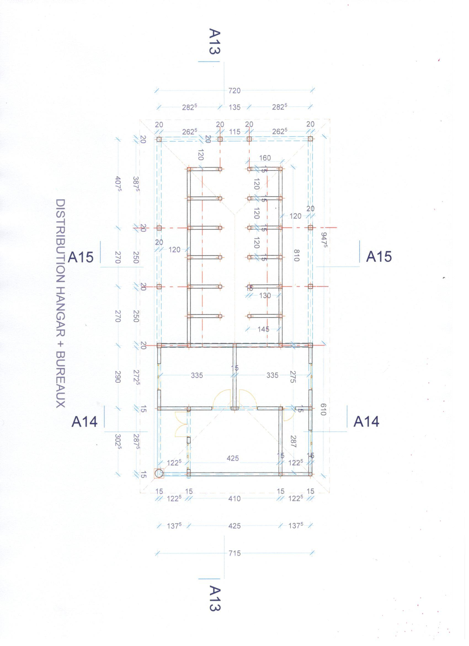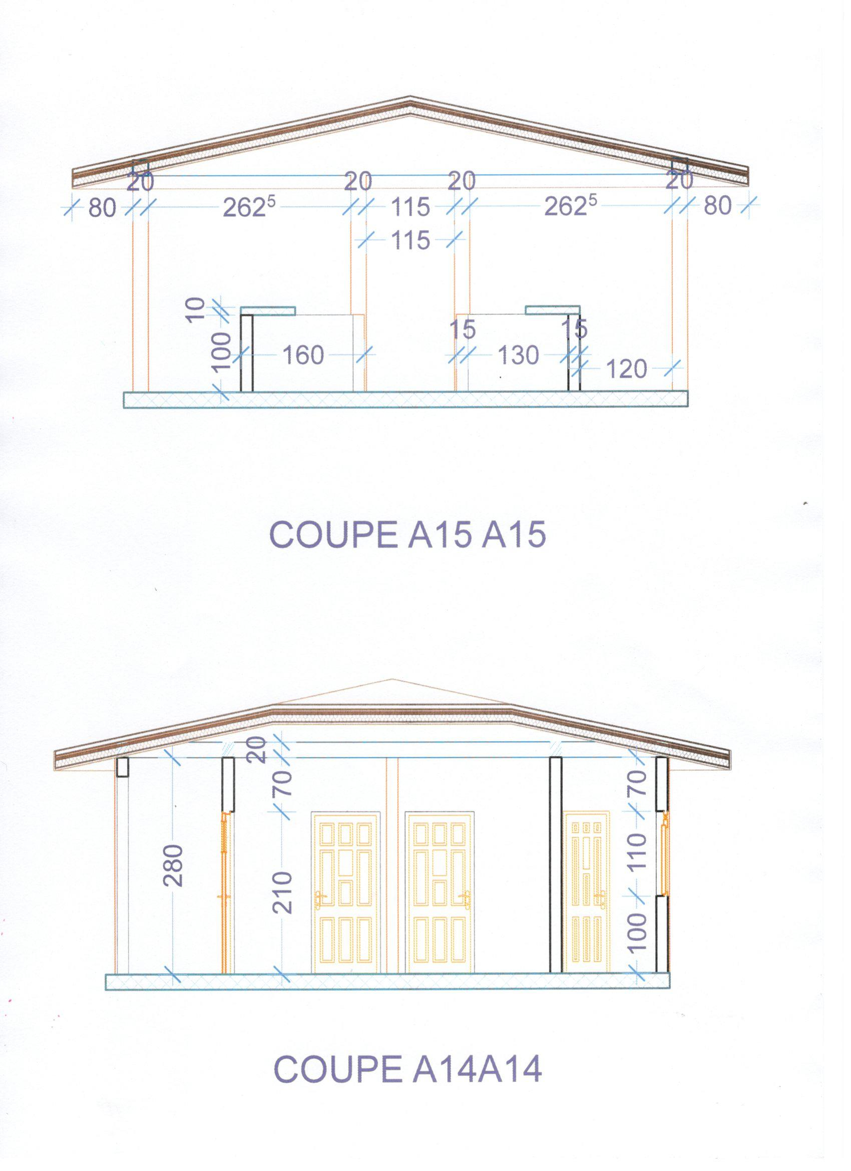

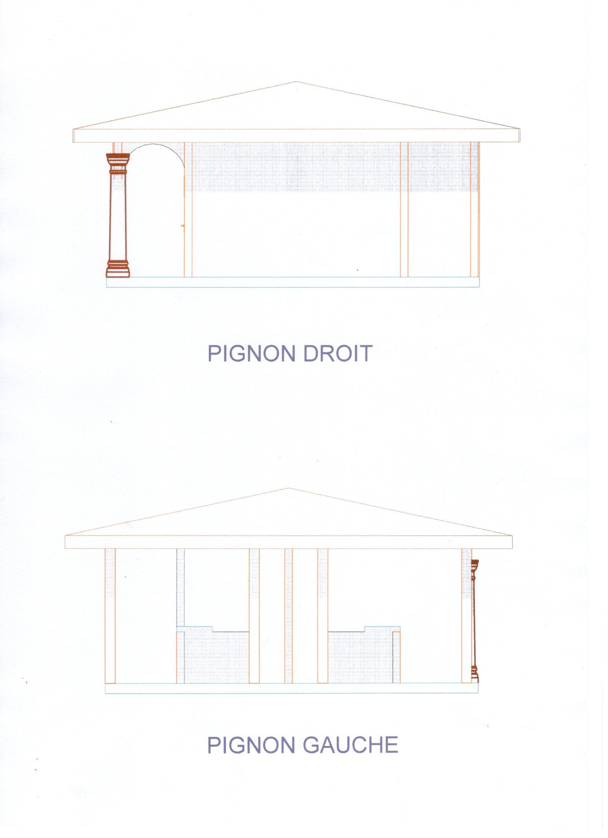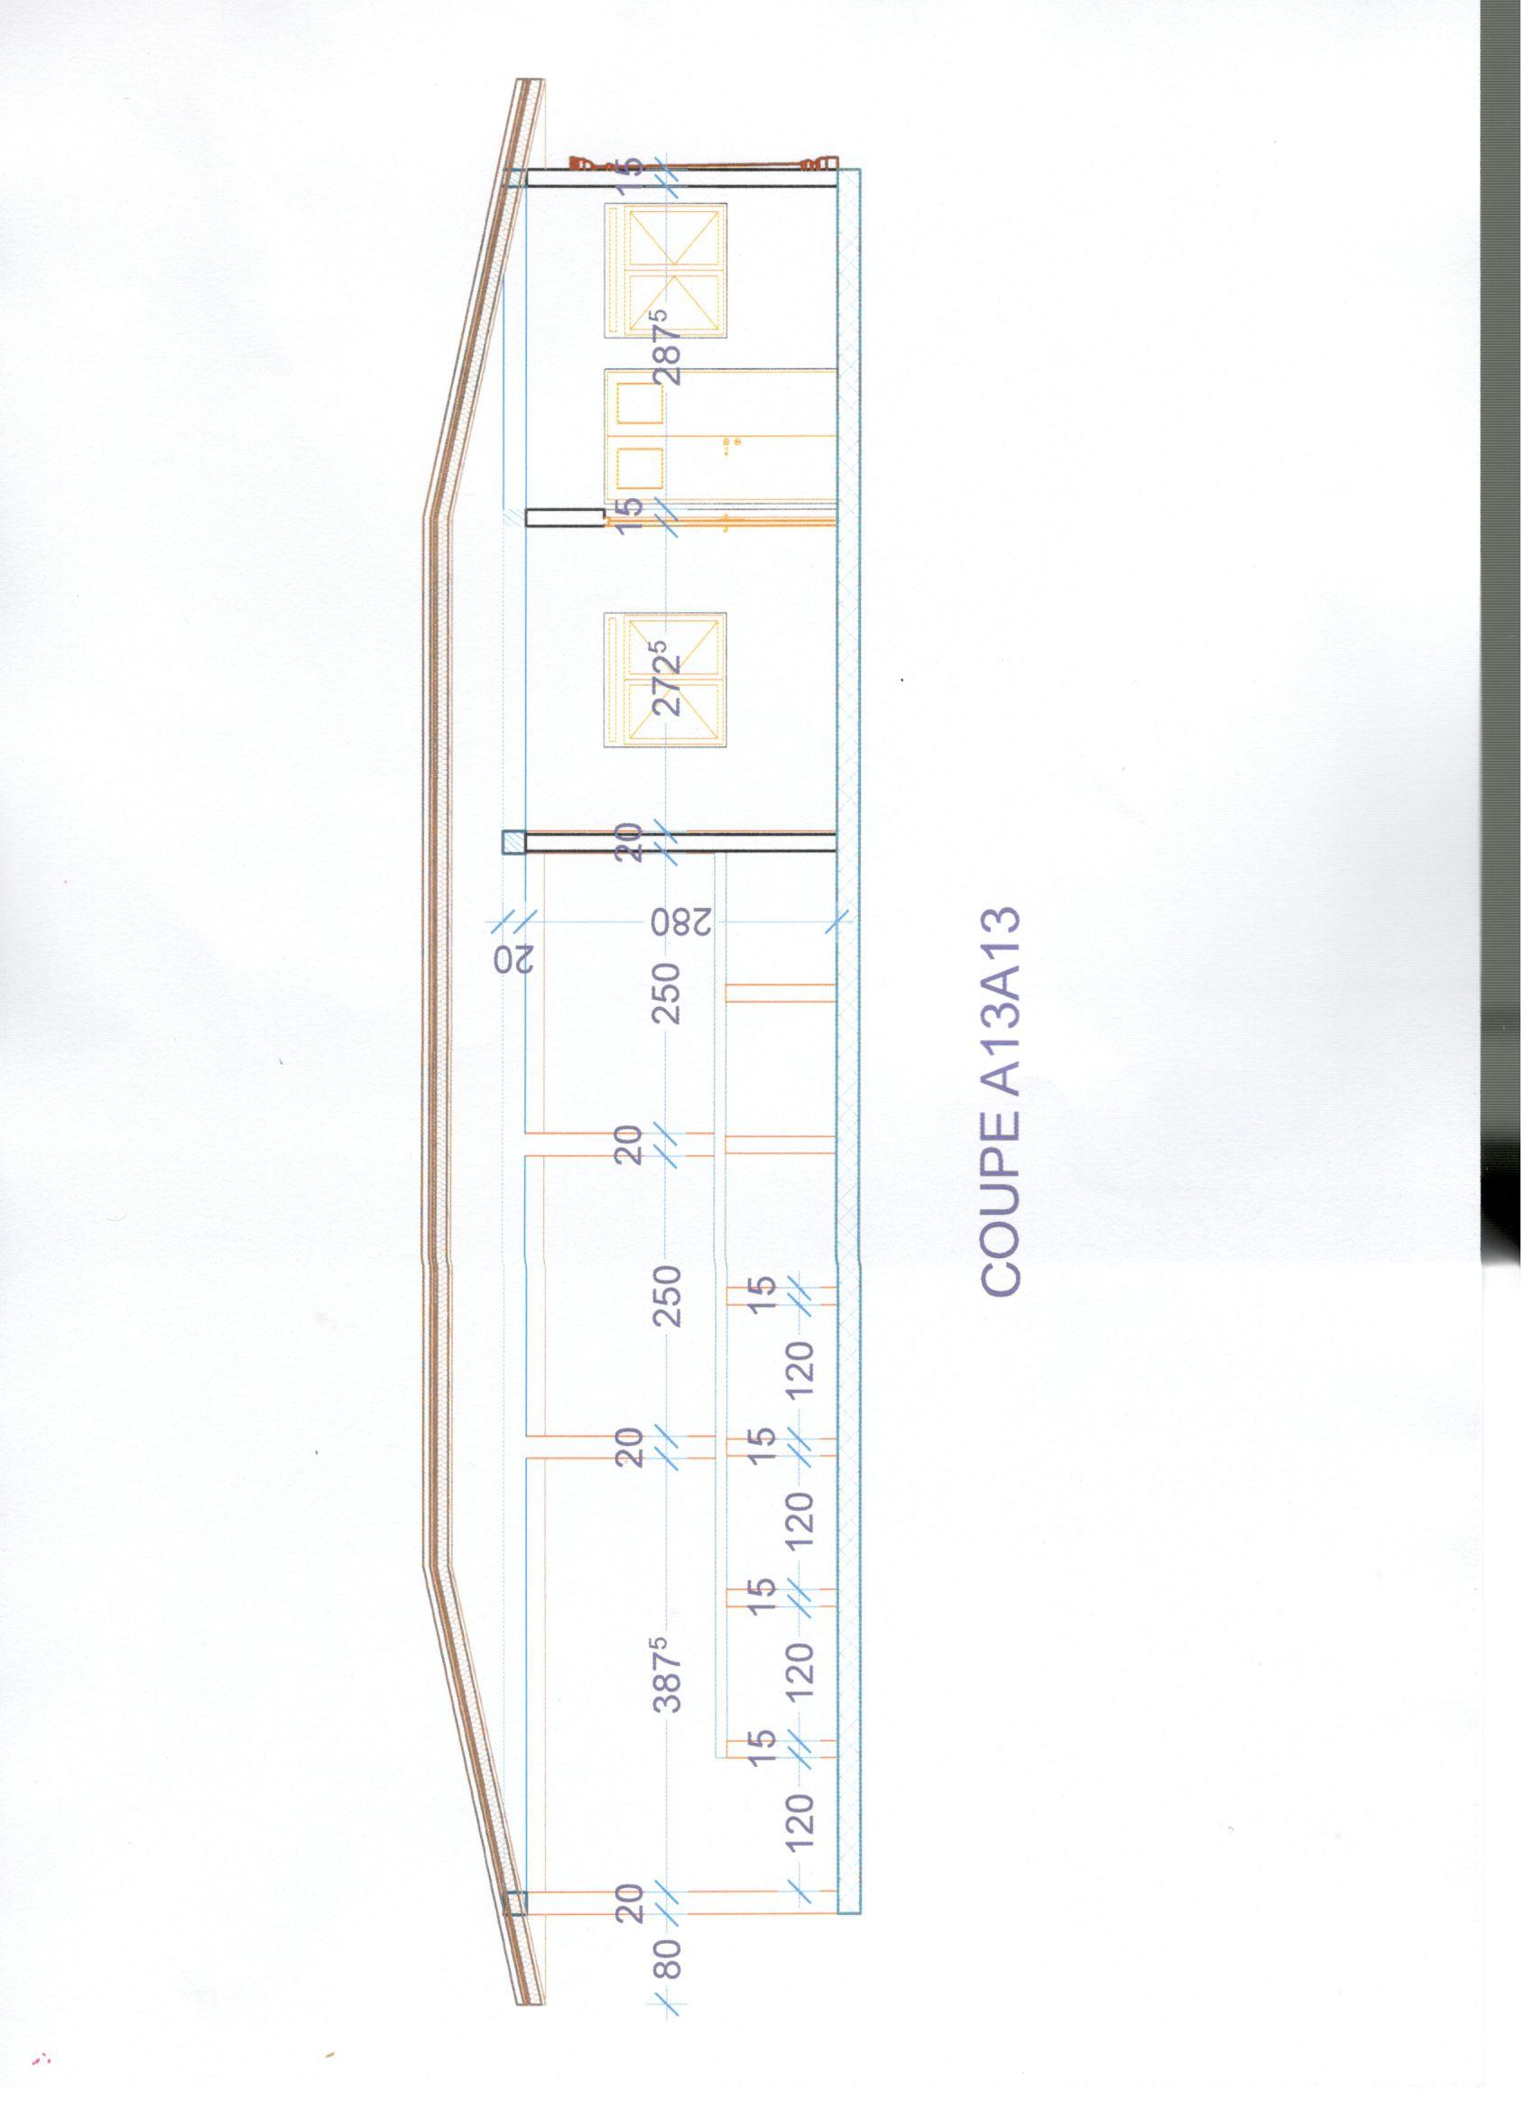

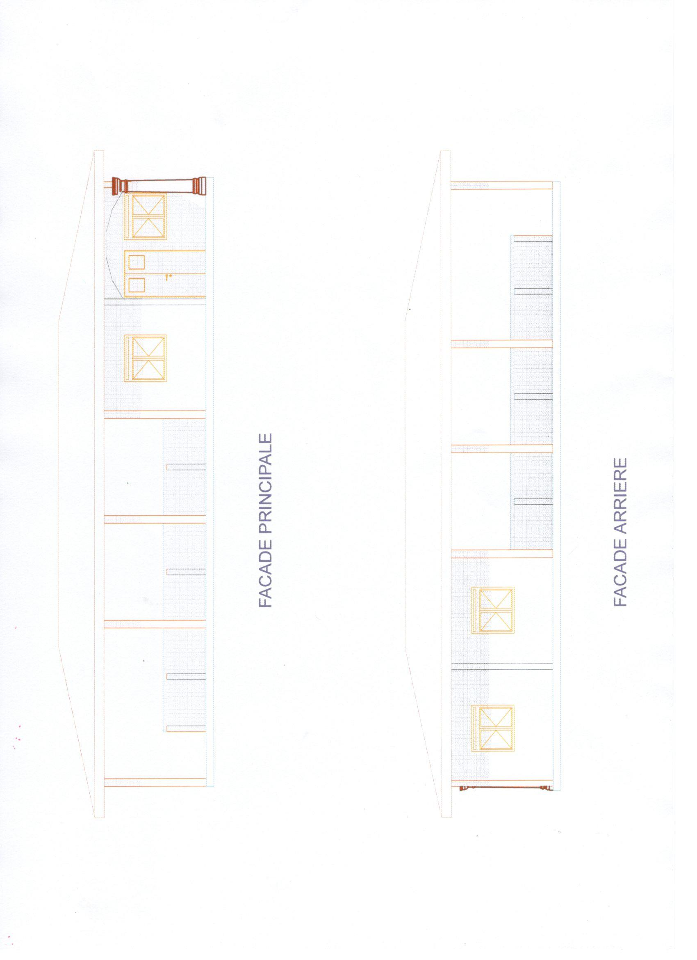

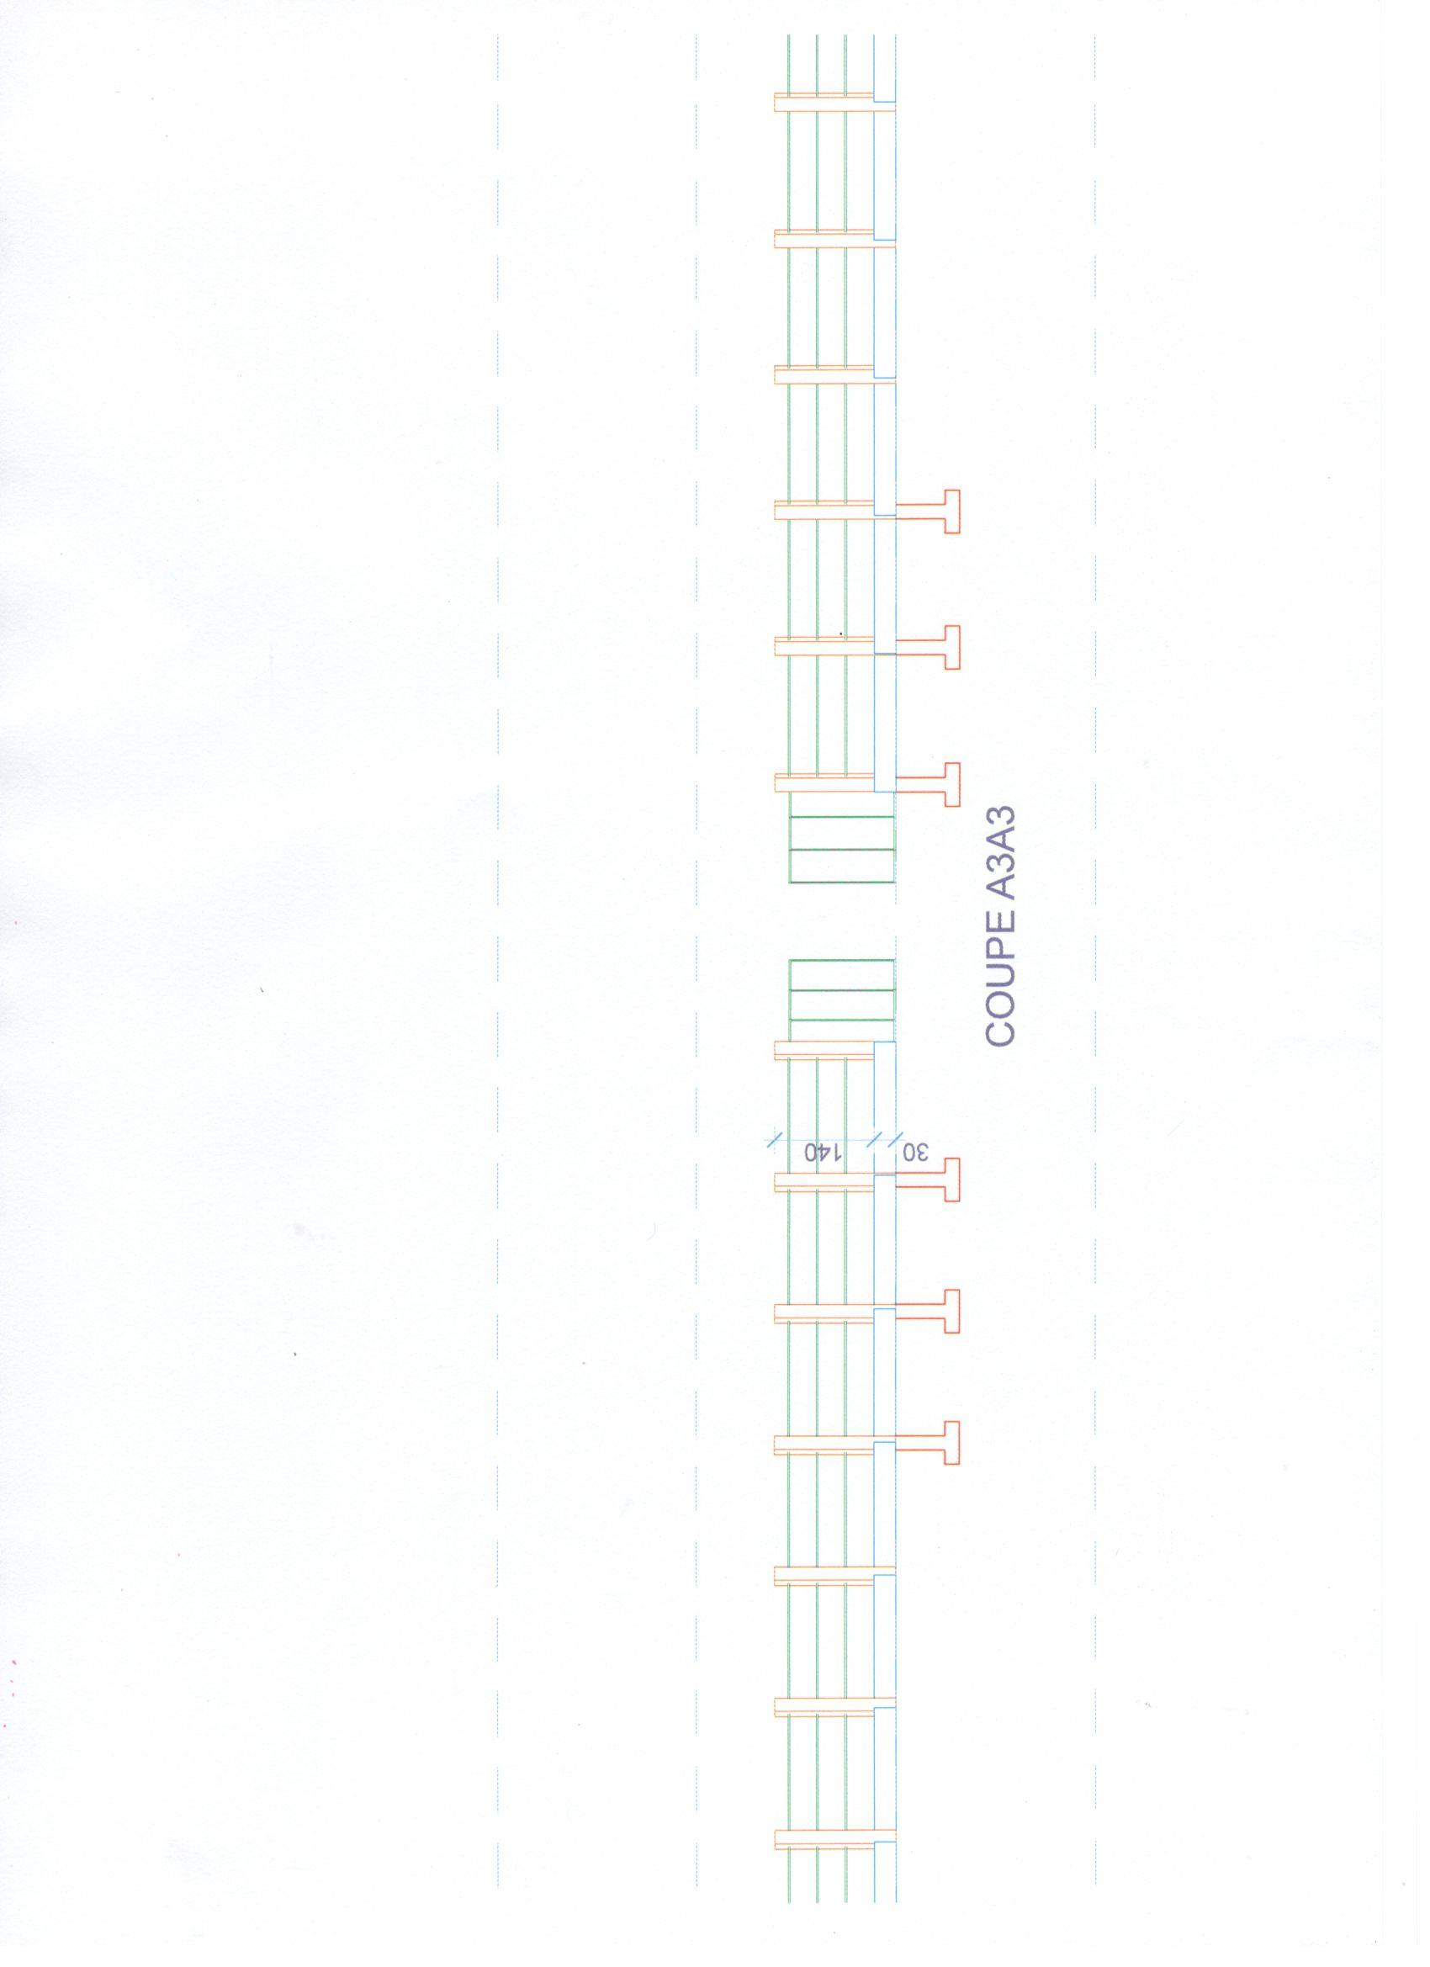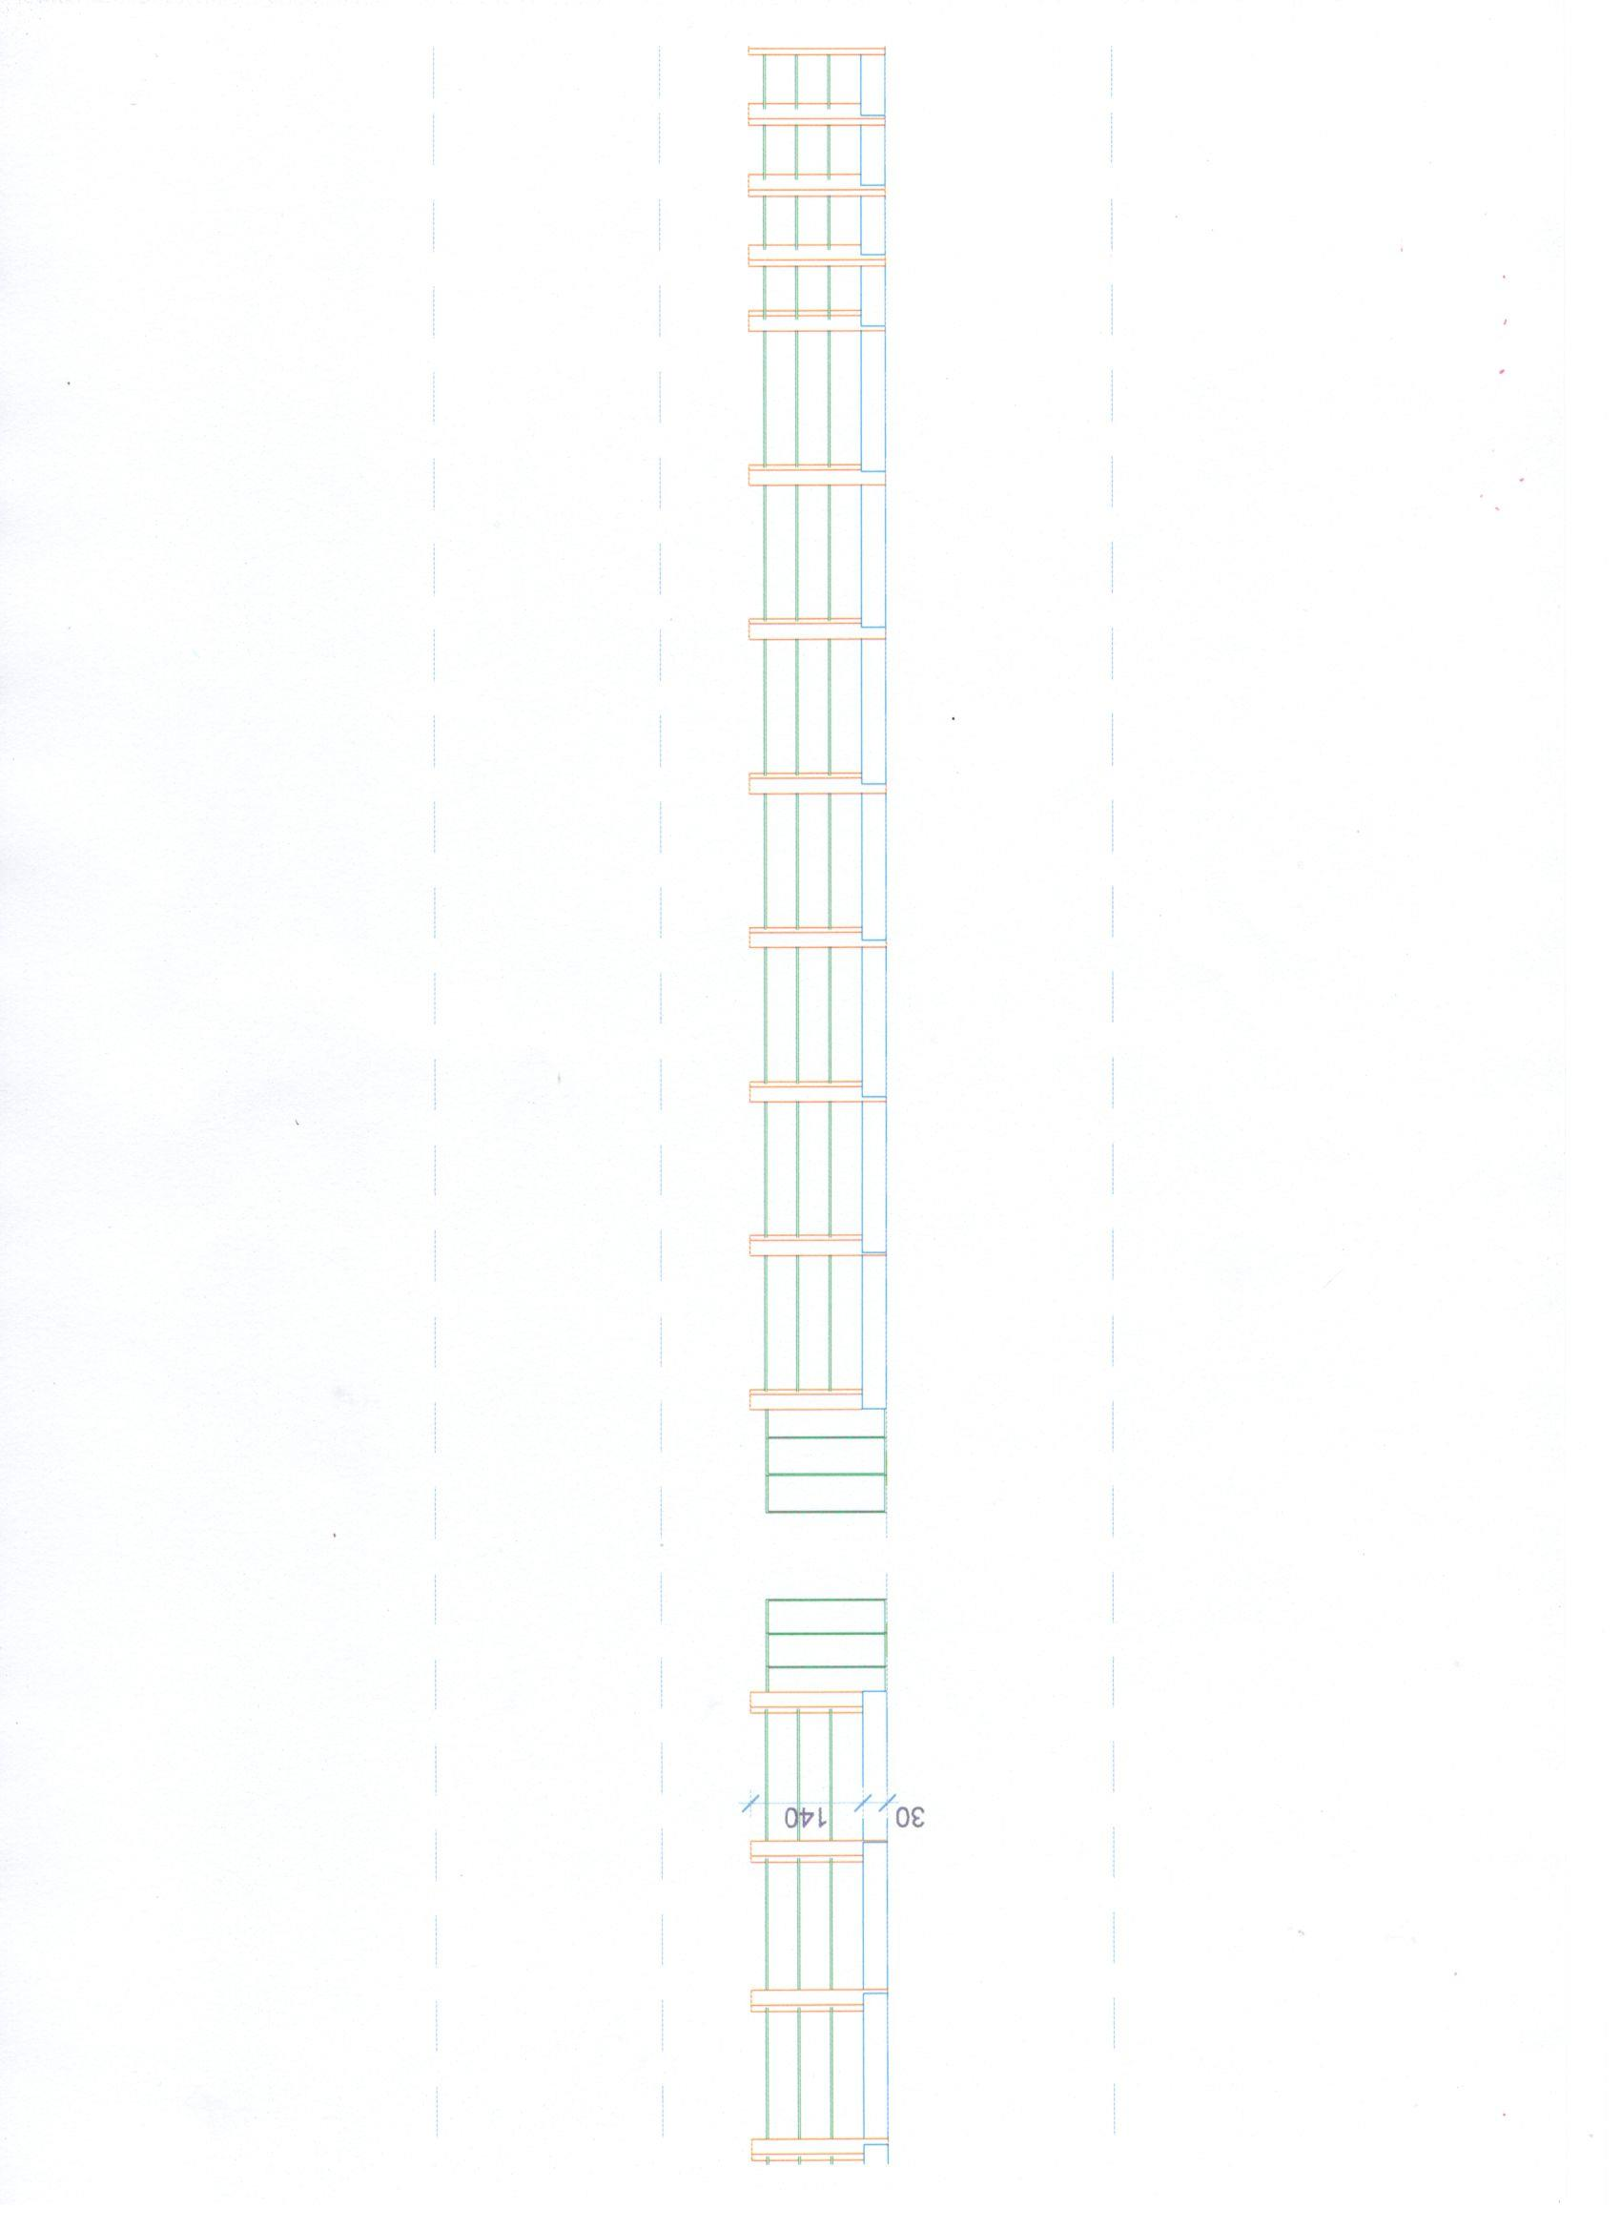

Individuals in a HH are estimated at 5 persons. A local group is composed of 11 individuals (average)
GIC stands for Groupe d’Initiative Commun (Common Initiative Group in English)
ORSEC stands for Organisation des Secours (Rescue Organisation)
GIC stands for Groupe d’Initiative Commun (Common Initiative Group in English)

